Microbiology · Exam 3 — Study Guide
Editable Word copy of the PA_Quizzes study aid. Headings use real Word styles, so the navigation pane and the contents field below both work, and restyling one heading restyles them all.
[In Word: right-click here and choose Update Field to build the contents.]

14 · Gram-Negative Bacilli of Medical Importance
Dr. Webster · Lecture 14 · 23 October 2026
INSTRUCTIONAL OBJECTIVES
- Compare and contrast the morphology, medium, laboratory tests, biochemical reactions, diseases, clinical manifestations, methods of treatment, and prevention of Gram-negative bacilli of medical importance.
- Describe the modes of transmission by which humans acquire Gram-negative bacilli of medical importance.

NOTE
One weapon, three questions. Every Gram-negative rod carries endotoxin, the lipopolysaccharide of its outer membrane (14.1). Then three questions sort them (14.2): what oxygen does it need, does it ferment lactose, is it oxidase positive? The aerobes that do not ferment are Pseudomonas and its relatives, Brucella, Francisella, Bordetella and Alcaligenes, with Legionella paired alongside Bordetella; the facultative anaerobes are the enterics, split into lactose-fermenting coliforms (Escherichia, Klebsiella, Enterobacter, Citrobacter) and non-lactose-fermenting non-coliforms (Proteus, Salmonella, Shigella, Yersinia), plus the oxidase-positive Haemophilus and Pasteurella. The syllabus points to its Appendix 2 list of eighteen organisms for this lecture (slides 3–4 reproduce it): Pseudomonas aeruginosa and the genera like it, Brucella, Francisella tularensis, Bordetella pertussis, Legionella, the coliform and non-coliform enterics of the normal flora, the four Escherichia coli pathotypes (enterotoxigenic, enteroinvasive, enteropathogenic, enterohemorrhagic O157:H7), Proteus, Salmonella typhi and the other salmonellae, Shigella, Yersinia pestis and Haemophilus. Objective 1 is answered organism by organism against its own headings (morphology, medium, tests, biochemistry, disease, manifestations, treatment, prevention); objective 2 is drawn together in 14.20.

★ PROFESSOR EMPHASIS
★ From the lecture recording — 23 October 2026
About 2 hours 4 minutes with Dr. Webster, in three parts (a classmate’s recording; parts start at 0:00, 46:13 and 1:31:32, and the times below run from the start). One transcript only: the recording came without Notability’s own transcript, so there is no second opinion to compare against, and quotes below are from a single machine transcription (organism names it misheard are written correctly here). Every factual claim was checked against the deck; where the two differ, the slide is what this guide teaches. She read the slides closely and corrected none of them.
She signposts little, so the quizzes are weighted by time spent on each organism group, stories and outbreak tallies taken out: Escherichia coli and its four pathotypes about 17 minutes, Pseudomonas aeruginosa 14, Yersinia pestis 12 (5 of them outbreaks and history), endotoxin 10, the enteric family, media and antigens 9, Salmonella 9, Bordetella pertussis 8, Legionella 8 (mostly outbreaks), the other coliforms 7 (mostly Serratia stories), Shigella 5, the Pseudomonas relatives and Haemophilus 4 each, Brucella and Proteus with its relatives 3½ each, the sorting scheme 3, Francisella 2, and the enteric yersinias, Pasteurella and Alcaligenes about a minute each.
What was said | What it means for you
“There are four different strains of E. coli that you need to know. Hint, hint, hint, hint.” [1:04:18] | The one plain signpost of the lecture. 14.11: enterotoxigenic, enteroinvasive, enteropathogenic and enterohemorrhagic O157:H7, each with its mechanism, disease, source, test and prevention. Every quiz set carries all four.
“I’m not going to be testing on which antibiotics, because that’s where we have our PDRs [Physicians’ Desk Reference].” [26:25] | Drug lists stay in the guide for completeness; no question asks which antibiotic treats what. Non-drug management (fluids and electrolytes, dialysis, plasmapheresis, combination therapy for multidrug resistance, vaccines, breast feeding, quarantine) is fair game.
“Very, very, very common with cystic fibrosis patients.” [23:53] | The slide’s own starred fact (14.3): Pseudomonas aeruginosa in burns, neoplastic disease and cystic fibrosis; and Burkholderia cepacia with it in cystic fibrosis (14.4).
“Endotoxin isn’t something to be ignored. And you have to remember that any gram-negative organism will have that weapon at its disposal.” [9:37] | 14.1: lipid A, release on lysis, the protective low-level response and the septic-shock flood.
“You do not have to memorize this diagram again.” [5:20] | Slide 8’s diagram of endotoxin’s targets (not reproduced here). The text she walked through (complement, coagulation, platelets, neutrophils, macrophages; slides 9–10) is in 14.1.
“You do not need to memorize all of this. But just know that it can basically hit you pretty much anywhere.” [25:02] | Slide 19’s body map of Pseudomonas infections (14.3): not asked site by site. The infections of healthy people (rashes, urinary tract infection, swimmer’s ear, corneal ulcers in contact lens wearers) are on the slide’s text and are asked.
“You don’t need to worry about the percentages or anything like that.” [56:17] | Slide 45’s share of nosocomial infections, and percentages generally: none is asked.
“I’m not asking you to memorize this chart.” [57:12] | Slide 47’s biochemical tree (14.10). Know what it starts from (lactose fermentation on triple sugar iron); the branches are not asked.
“There seems to be a relationship, association, not causation” [1:29:03] | Proteus and bladder and kidney stones (14.13): an association, not a proven cause.
“You have to diagnose it quickly in order to be able to control it because you can have death occurring within about two days of your first symptoms.” [1:53:30] | Plague diagnosis (14.17): history (“where have you been? Have you been around little critters lately?”), symptoms and aspiration of the bubo.

Things said that are not on a slide — consistent with the deck, useful as hooks, not asked:
- Killing Gram-negatives with an antibiotic releases a surge of endotoxin, “why a lot of times when you’re treating for a gram-negative, you feel a whole lot worse before you start feeling better” [1:11].
- Pseudomonas aeruginosa smells like rotten grapes [23:27]; contact lens wearers should take the lenses out, clean them and store them in solution every day [25:27], which also guards against Stenotrophomonas [31:52].
- Raw milk: “pasteurization is a good thing” [33:34] (Brucella, and again for enterohemorrhagic Escherichia coli from raw milk and cheese [1:16:58]). Hunters of wild rabbits catch tularemia [36:13].
- Pertussis boosters are now recommended for older adults as well [41:52].
- Legionella: “Pontiac fever” was the name of the illness before the 1976 outbreak, and saved tissue later showed the same organism [49:24].
- Breast feeding protects against enteropathogenic Escherichia coli because the immunoglobulin A in colostrum and breast milk coats the intestinal lining and keeps the organism from adhering [1:10:16].
- The Klebsiella capsule stain is done in India ink: the capsule does not take up the ink and shows as a clear halo [1:21:43]. Serratia grows in bathroom grout lines (the tile photograph on slide 68) [1:24:12].
- Typhoid Mary (Mary Mallon), a cook in New York City, was an asymptomatic carrier [1:33:52].
- Plague in the United States reaches campers in rodent country, by fleas that get into the tent; there has been no human-to-human transmission in the United States since 1924 [1:47:58].
- The dental-procedure endocarditis of H. parainfluenzae and H. aphrophilus is why people with cardiac conditions take antibiotics before a dental cleaning [2:03:13].

14.1 · Objective 1 — Endotoxin, the shared weapon
Endotoxin is a structural component of the Gram-negative outer membrane. Chemically it is lipopolysaccharide; lipid A is the biologically active component of the complex, the part most responsible for pathogenesis. It is released on the lysis of Gram-negative cells, including through antibiotic therapy, and as bacterial cells grow and divide, particularly when they are rapidly proliferating.
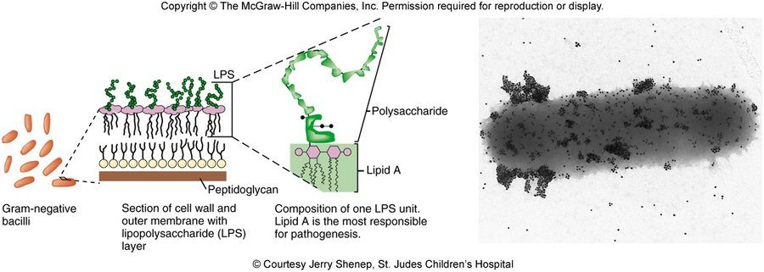
Where endotoxin sits. The lipopolysaccharide layer is the outside of the outer membrane, above the peptidoglycan. In each unit a polysaccharide chain rides on lipid A , labeled here as the part most responsible for pathogenesis. Copyright © The McGraw-Hill Companies. Source: Lecture 14 Dr. Webster Gram Negative Bacilli of Medical Importance.pptx, Slide 5.
Part of the lipopolysaccharide | What it is
Lipid A | The lipid region to which the polysaccharide is bound; the biologically active component
Core polysaccharide | Identical for large groups of bacteria, with some unique sugars
O antigen polysaccharide | Unique for each organism; repeating units of 3–4 different hexoses. The number of repeating units designates the antigen as rough, semi-rough or smooth

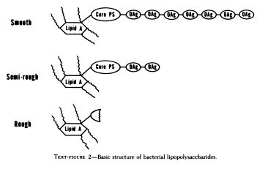
Smooth, semi-rough, rough. The more repeating O antigen units on the core, the smoother the lipopolysaccharide; a rough one has none. Source: Lecture 14 Dr. Webster Gram Negative Bacilli of Medical Importance.pptx, Slide 6.

What endotoxin does
- Usually protective. In the gut and airways the first contact between epithelium and Gram-negative bacteria is the outer membrane and its lipopolysaccharide. These are antigens of the innate (nonspecific) immune system, signaling through a lipopolysaccharide binding complex and a Toll-like receptor. Under most circumstances this gives a moderated, protective inflammatory response, which keeps most mucosal infections mucosal and helps maintain our symbiosis with some Gram-negative bacilli.
- Chronic infection. Some bacteria have adapted by modifying their lipopolysaccharide to evade the immune system.
- Potentially damaging, through complement, coagulation and a variety of cells:
- Complement turns on by the classical pathway (antigen-antibody reaction) or the alternative pathway, and can result in hemorrhagic necrosis.
- Coagulation: tissue injury through coagulation changes, disseminated intravascular coagulation; fibrin deposited in the lungs, liver and spleen; it may trigger bradykinin, a vasodilator in shock.
- Platelets: altered activity causing aggregation (differs among species). Neutrophils: low levels may enhance phagocytosis, but higher levels may interfere with chemotaxis to the site of infection. Macrophages release pro-coagulants, collagenase, pyrogens, prostaglandins, colony stimulating factor, tumor necrosis factor, interleukin 1 and interleukin 6, nitric oxide and reactive oxygen species.
Low dose against flood. Low levels of endotoxin give a low-level inflammatory response: fever, malaise, aches and pains. A large flood releases the mediators and contributes to septic shock: tumor necrosis factor and interleukin 1 make neutrophils stick to endothelium and activate clotting, forming microthrombi throughout the body; arteries and arterioles dilate, peripheral arterial resistance falls and cardiac output at first rises (warm shock); later cardiac output falls and blood pressure drops, leading to tissue hypoxia, infarction and multisystem organ failure.

14.2 · Objective 1 — Sorting the Gram-negative bacilli
The Gram-negative bacilli are differentiated by three properties: oxygen requirement (aerobic, facultatively anaerobic, obligate anaerobic), the ability to ferment lactose, and the oxidase enzyme.
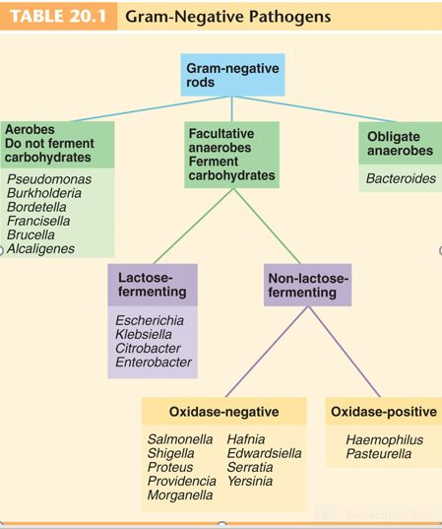
The scheme for the whole lecture (Table 20.1). Oxygen first, then lactose, then oxidase. Note where Serratia and Hafnia sit here (non-lactose-fermenting) against slide 50, which calls them coliforms (14.21). Source: Lecture 14 Dr. Webster Gram Negative Bacilli of Medical Importance.pptx, Slide 12.
Aerobic Gram-negative nonenteric bacilli are a large, diverse group of non-spore-forming bacteria, from habitats as varied as the large intestine, animals, the respiratory tract, soil and water. Most are not medically important; some are true pathogens and some opportunists. All use endotoxin as one of their offensive weapons. (The third branch of the scheme, the obligate anaerobes, is Bacteroides.) The medically important aerobic genera fall in three pairs:
Pair | Kind of pathogen
Pseudomonas and Burkholderia | Opportunistic pathogens
Brucella and Francisella | Zoonotic pathogens
Bordetella and Legionella | Mainly human pathogens

14.3 · Objective 1 — Pseudomonas aeruginosa
Heading | The pseudomonads, and Pseudomonas aeruginosa
Morphology | Small Gram-negative rods with a single polar flagellum
Habitat | Free living, primarily in soil, sea water and fresh water; also colonize plants and animals. Important decomposers and bioremediators (exoenzymes such as protease, amylase, pectinase and cellulase; oil-eating and pesticide-clearing strains); frequent contaminants in homes and clinical settings; food spoilage (dairy, meat, eggs). P. aeruginosa: soil and water, an intestinal resident in 10% of normal people, also on skin and in saliva
Biochemistry | Aerobic respiration; do not ferment carbohydrates (aerobic respiration, no fermentation). Produce oxidase and catalase. Produce pseudomycins (antifungal agents). Many make water-soluble pigments (blue-green, yellow-green, brown, red)
Identifying signs | Grapelike odor; greenish-blue pigment, pyocyanin
Hardiness | Resistant to soaps, dyes, quaternary ammonium disinfectants, drugs and drying; survives in nutrient-poor environments; a major agent of nosocomial infections
Why it contaminates equipment | Frequent contaminant of ventilators, intravenous solutions and anesthesia equipment because it produces biofilms

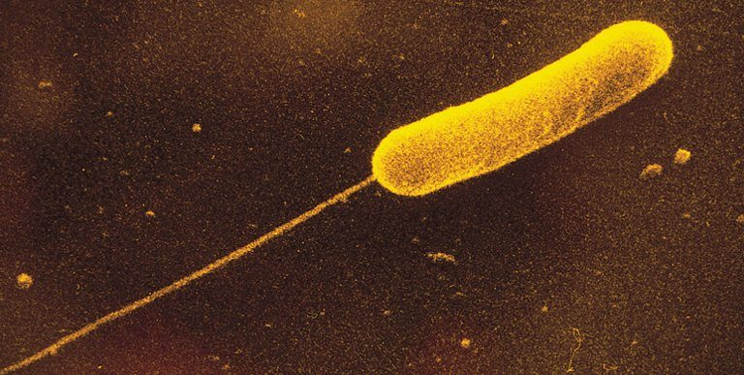
One polar flagellum , the pseudomonad pattern. Compare the peritrichous flagella of Proteus (14.13). Source: Lecture 14 Dr. Webster Gram Negative Bacilli of Medical Importance.pptx, Slide 15.
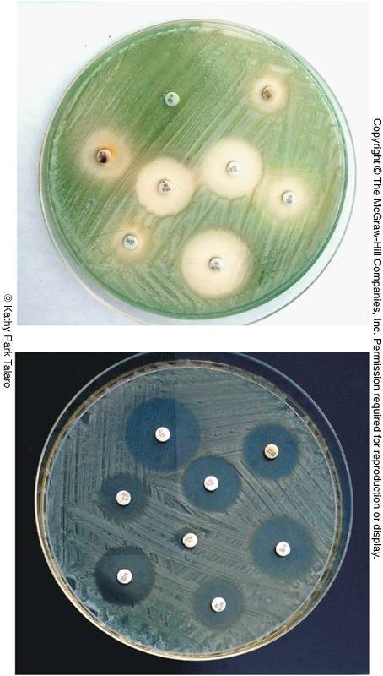
The pigment colors the medium. Pseudomonas aeruginosa growing on two plates; its water-soluble pigment stains the agar greenish-blue. Copyright © The McGraw-Hill Companies. Source: Lecture 14 Dr. Webster Gram Negative Bacilli of Medical Importance.pptx, Slide 16.

Virulence and resistance
- Exotoxin A inhibits protein synthesis.
- Slime layer: resistance to phagocytosis and biofilm formation. Cells in biofilms adhere by flagella and pili and form microcolonies; three polysaccharides stabilize the biofilm and impair bacterial clearance.
- Exoenzymes: exoenzyme S induces apoptosis of T cells; others degrade phospholipid.
- Multidrug resistant, through restricted outer membrane permeability, which limits drug entry, antibiotic-inactivating enzymes, efflux pumps, horizontal transfer of resistance genes and biofilm formation. The slide notes it is one of the top three critical pathogens the World Health Organization prioritized for research into new treatments (with Acinetobacter baumannii and Escherichia coli; see 14.21).
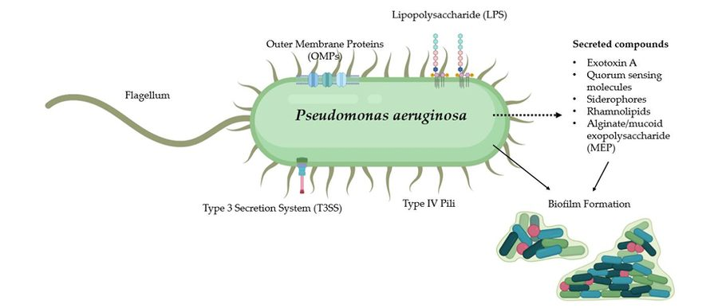
The virulence kit : flagellum and type IV pili for attachment, secreted exotoxin A and alginate, and biofilm formation. Source: Lecture 14 Dr. Webster Gram Negative Bacilli of Medical Importance.pptx, Slide 18.

Disease
- A common cause of nosocomial infection in hosts with burns, neoplastic disease and cystic fibrosis (the slide stars cystic fibrosis with three asterisks). Complications include pneumonia, urinary tract infection, abscesses, otitis and corneal disease; septicemia leads to endocarditis, meningitis and bronchopneumonia.
- Typical infections in healthy people: skin rashes, urinary tract infection, otitis externa (swimmer’s ear), and corneal ulcers in contact lens wearers.
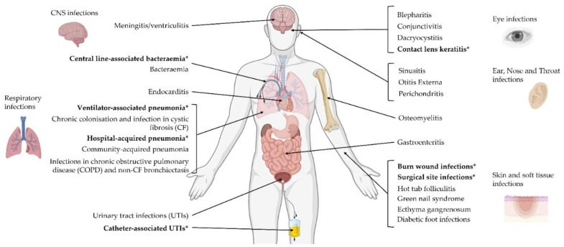
Everywhere it can reach. Starred on the figure: contact lens keratitis, central line-associated bacteremia, ventilator-associated and hospital-acquired pneumonia, burn wound and surgical site infections, and catheter-associated urinary tract infections. The ear panel carries otitis externa, swimmer’s ear. Not to memorize site by site, the recording says; know that it can hit almost anywhere. Source: Lecture 14 Dr. Webster Gram Negative Bacilli of Medical Importance.pptx, Slide 19.
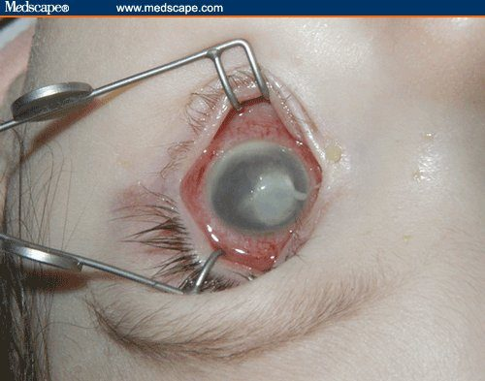
A corneal ulcer , the Pseudomonas aeruginosa infection of contact lens wearers. Medscape. Source: Lecture 14 Dr. Webster Gram Negative Bacilli of Medical Importance.pptx, Slide 19.
Treatment and prevention. The antibiotics listed are cephalosporins, aminoglycosides, carbenicillin, polymyxin, quinolones and monobactams. A vaccine is in development, particularly for cystic fibrosis patients: most candidates rely on antibodies against bacterial protein; one uses the PopB protein to stimulate T helper 17 cells, which release interleukin 17 and enhance antibacterial mucosal defenses; one in current testing uses the porin membrane protein OprH and has worked against at least two strains. But in cystic fibrosis, where the infection is often chronic, vaccination may induce increased pulmonary inflammation and tissue damage: it may worsen lung inflammation. Mucosal delivery by liposomes and nanoparticles is being investigated.

14.4 · Objective 1 — Burkholderia , Acinetobacter , Stenotrophomonas
The related Gram-negative aerobic rods are similar to the pseudomonads: wide habitats in soil, water and related environments; obligate aerobes that do not ferment sugars; opportunistic pathogens. (The slide also calls them motile and oxidase positive; see 14.21.)
Organism | Where it lives and how it gets in | Disease | Notes
Burkholderia cepacia | Biodegrades many substances; a plant pathogen | Opportunist of the respiratory tract, urinary tract and skin | Rapidly mutates; multidrug resistant; a particular problem in cystic fibrosis, as a copathogen with Pseudomonas (an 80% fatality)
Burkholderia pseudomallei | Soil and water of tropical climates; acquired through a penetrating injury or inhalation | Melioidosis: wound infection with localized nodules, fever and muscle aches; bronchitis and pneumonia; septicemia; endotoxic shock; liver and brain abscesses | The body map adds parotitis, bone, joint, genitourinary and skeletal-muscle infection
Acinetobacter baumannii | Nosocomial and community acquired; survives months on fomites | Wounds, lungs, urinary tract, burns, blood; infections after traumatic (combat) wounds; the immunocompromised | Also listed as needing urgent research; multidrug resistant, so combination treatment (carbapenems, polymyxin B, ampicillin)
Stenotrophomonas maltophilia | Fresh water, soil, fecal flora of humans and domestic animals; forms biofilms; contaminates disinfectants, dialysis and respiratory equipment, water dispensers and catheters | Isolated from respiratory, soft tissue, blood, cerebrospinal fluid and eye specimens | Multiple drug resistance; combination therapy (cephalosporins, tetracyclines, fluoroquinolones, penicillins)

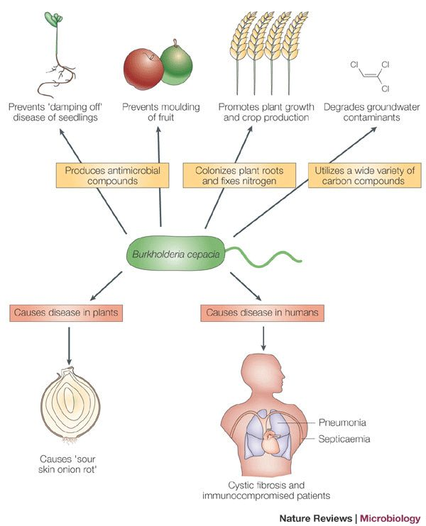
Useful in soil, dangerous in cystic fibrosis. The same organism protects crops and degrades pollutants, rots onions, and causes pneumonia and septicemia in cystic fibrosis and the immunocompromised. Nature Reviews Microbiology. Source: Lecture 14 Dr. Webster Gram Negative Bacilli of Medical Importance.pptx, Slide 22.
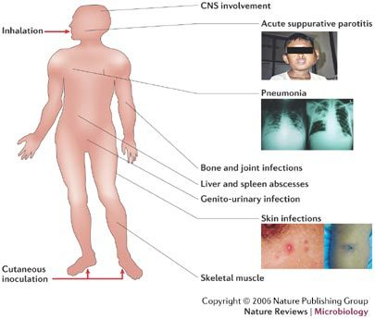
Melioidosis , Burkholderia pseudomallei : in through the lungs or a skin wound, then almost any organ. Copyright © 2006 Nature Publishing Group, Nature Reviews Microbiology. Source: Lecture 14 Dr. Webster Gram Negative Bacilli of Medical Importance.pptx, Slide 24.

14.5 · Objective 1 — Brucella and brucellosis
Heading | Brucella
Morphology | Tiny Gram-negative coccobacilli
Species | Brucella abortus (cattle) and Brucella suis (pigs)
Disease names | Brucellosis: Malta fever, undulant fever, Bang disease
Transmission | A zoonosis of animal handling and slaughtering: contact with the blood, urine or placentas of infected animals, or unpasteurized dairy products (raw dairy). Human-to-human transmission is rare
Pathogenesis | Enters through damaged skin or mucous membranes; phagocytes carry it to the blood, with lesions in the liver, spleen, bone marrow and kidneys
Manifestations | A severe febrile illness with a fluctuating fever over weeks to a year (undulant fever); chills, sweating, headache, muscle pain, weight loss
Laboratory test | Serological: an agglutination titer test
Treatment | A combination of tetracycline and rifampin or streptomycin
Prevention | An animal vaccine is available. A potential bioweapon

14.6 · Objective 1 — Francisella tularensis and tularemia
Heading | Francisella tularensis
Disease | Tularemia, rabbit fever: a zoonosis of mammals endemic to the northern hemisphere, particularly rabbits
Transmission | Contact with infected animals, water and dust, or bites by vectors. The infective dose is very small (10–50 organisms)
Course | Incubation of days to 3 weeks; headache, backache, fever, chills, malaise and weakness; ulcerative skin lesions and swollen lymph nodes; sore throat, intestinal involvement and respiratory infection. A 10% death rate in the systemic and pulmonic forms
Relapse | Intracellular persistence can lead to relapse
Treatment and prevention | Gentamicin or tetracycline; an attenuated vaccine. A potential bioterrorism agent

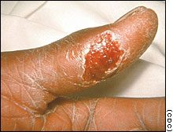
The ulcerative skin lesion of tularemia , here on a finger, the kind of entry site left by handling an infected animal. Centers for Disease Control and Prevention. Source: Lecture 14 Dr. Webster Gram Negative Bacilli of Medical Importance.pptx, Slide 29.

14.7 · Objective 1 — Bordetella pertussis and whooping cough
Heading | Bordetella pertussis
Morphology | Minute, encapsulated coccobacillus
Disease | Pertussis, whooping cough: a communicable childhood acute respiratory syndrome, often with severe, life-threatening complications in babies; about half of cases are in children from birth to 4 years
Reservoir and transmission | Reservoir: apparently healthy carriers. Transmission by direct contact or inhalation of aerosols
Virulence | Receptors that recognize and bind ciliated respiratory epithelial cells; toxins that destroy and dislodge ciliated cells, destroy phagocyte activity, and cause hemolysis and leukolysis. Loss of the ciliary mechanism leads to a buildup of mucus and blockage of the airways
Stages | Catarrhal: nasal drainage, congestion, sneezing, occasional cough. Paroxysmal: recurrent persistent cough followed by a deep inhalation, the whoop. Complications come from compromised respiration
Treatment | Two weeks of erythromycin, azithromycin or trimethoprim-sulfamethoxazole (the slide uses the brand name Septra)
Prevention | DTaP (diphtheria, tetanus and acellular pertussis): an acellular vaccine containing toxoid and other antigens, a five-dose series between 2 months and 6 years; Boostrix for children and adolescents aged 10–18

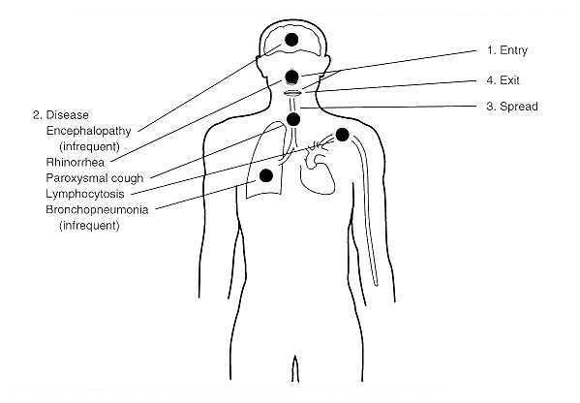
The course of pertussis : in and out through the airway; the disease itself is rhinorrhea, the paroxysmal cough and a lymphocytosis, with encephalopathy and bronchopneumonia as the infrequent complications. Source: Lecture 14 Dr. Webster Gram Negative Bacilli of Medical Importance.pptx, Slide 32.
Why pertussis is rising again.
- Infants under 2 months are too young to be vaccinated (they cannot get the vaccine), so incidence is highest under 1 year old (in Florida in 2023, over half of reported cases were not up to date on vaccination).
- The age pattern in older children and adolescents reflects waning immunity from childhood vaccination and the need for booster doses.
- “Another possible connection”: pertactin-negative strains are now developing. Pertactin is the protein that helps the bacterium adhere to airway linings and a vaccine component, and these strains lack it.

14.8 · Objective 1 — Alcaligenes
An aerobe of the non-fermenting branch (14.2), not on the syllabus list. Lives primarily in soil and water and may become normal flora. Alcaligenes faecalis is the most common clinical species, isolated from feces, sputum and urine; it is occasionally associated with opportunistic pneumonia, septicemia and meningitis.

14.9 · Objective 1 — Legionella and legionellosis
Heading | Legionella pneumophila
Morphology and stain | Weakly Gram negative; motile; rod shaped but pleomorphic, coccobacilli to filamentous
Culture | Cannot be easily cultured; grown on charcoal yeast extract agar
Habitat | Widely distributed in water: tap water, cooling towers, spas, ponds, air conditioning, supermarket vegetable sprayers. Lives in close association with amebas
Transmission | By aerosols. Outbreaks have come from a cooling tower and from the spray of a decorative fountain
Diseases | Legionellosis: Legionnaires disease (named for the 1976 epidemic of pneumonia among American Legion members at a convention in Philadelphia) and Pontiac fever
Who gets it | Males over 50; smokers; as a nosocomial disease, elderly patients with diabetes, cancer, transplants, chronic alcoholism or chronic lung disease
Manifestations | Fever, cough, diarrhea, abdominal pain, pneumonia
Treatment | Erythromycin with rifampin, azithromycin, quinolones

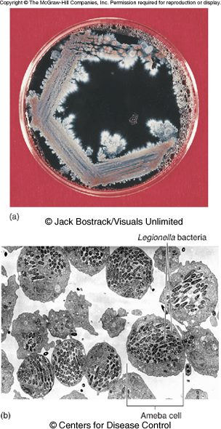
Panel (a) : Legionella pneumophila growing on charcoal yeast extract agar. Panel (b) : Legionella bacteria inside ameba cells, their home in water systems. Copyright © The McGraw-Hill Companies. Source: Lecture 14 Dr. Webster Gram Negative Bacilli of Medical Importance.pptx, Slide 41.

14.10 · Objective 1 — The Enterobacteriaceae: traits, media, antigens
The enterics are a large family of small, non-spore-forming Gram-negative rods. Many live in soil, water and decaying matter and are common occupants of the large bowel of animals, including humans. They are the most frequent cause of diarrheal disease, by enterotoxins or by invasive infection, and with Pseudomonas they account for almost half of nosocomial infections; they have been isolated from soap dishes, sinks, catheters and tracheal cannulas.
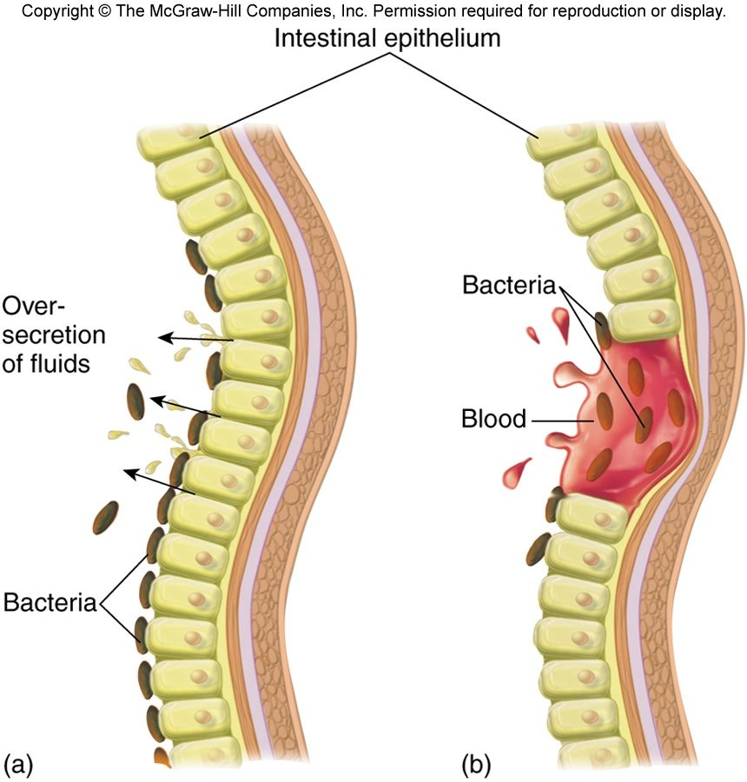
Two kinds of diarrheal disease. (a) Toxigenic : bacteria on the surface drive an oversecretion of fluids (example: enterotoxigenic Escherichia coli ). (b) Invasive : bacteria enter the lining and it bleeds (example: Shigella ). Copyright © The McGraw-Hill Companies. Source: Lecture 14 Dr. Webster Gram Negative Bacilli of Medical Importance.pptx, Slide 44.
Every enteric | Splits them
Facultative anaerobes, growing best in air. All ferment glucose, reduce nitrates to nitrites, are oxidase negative and catalase positive. All carry the O antigen | Lactose fermentation: coliforms ferment lactose, non-coliforms do not. Enrichment, selective and differential media screen samples for pathogens

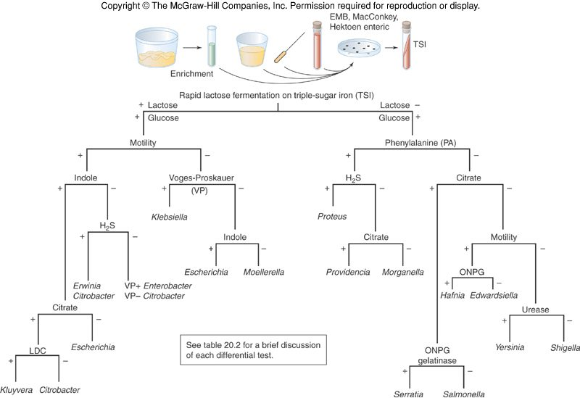
The biochemical tree. Rapid lactose fermentation on triple sugar iron splits the enterics; then motility, indole, hydrogen sulfide, Voges-Proskauer, phenylalanine, citrate and urease. Not to memorize, the recording says: it is here as a map of how the enterics are told apart. Kits such as the Enterotube II run many of these tests at once (slide 49). Copyright © The McGraw-Hill Companies. Source: Lecture 14 Dr. Webster Gram Negative Bacilli of Medical Importance.pptx, Slide 47.
Isolation medium | Selective for | Differential for
Eosin methylene blue (EMB) agar | Gram-negative bacteria; the selective agents are the dyes eosin and methylene blue | Lactose fermenters
MacConkey’s agar | Gram-negative bacteria; the selective agents are crystal violet and bile salts | Lactose fermenters

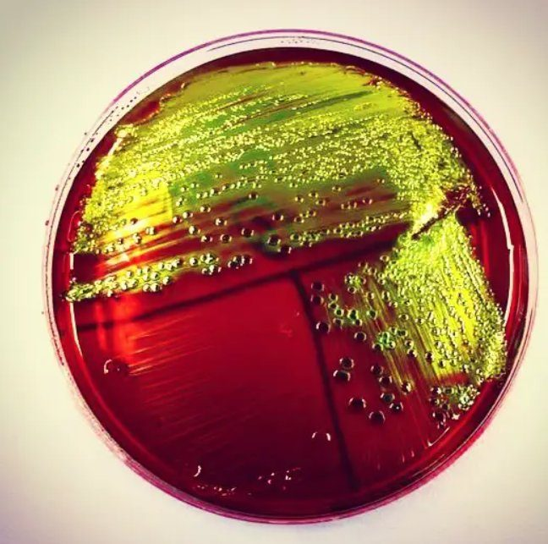
Eosin methylene blue agar. Source: Lecture 14 Dr. Webster Gram Negative Bacilli of Medical Importance.pptx, Slide 48.
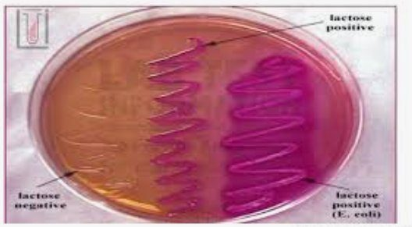
MacConkey’s agar. Lactose fermenters such as Escherichia coli come up pink; non-fermenters stay pale. Source: Lecture 14 Dr. Webster Gram Negative Bacilli of Medical Importance.pptx, Slide 48.
In the normal flora: coliforms | In the normal flora: non-coliforms | True pathogens
Escherichia coli, Enterobacter, Klebsiella, Hafnia, Citrobacter, Serratia (slide 50; see 14.21) | Proteus, Providencia, Morganella, Edwardsiella | Enteric: Salmonella typhi, S. cholerae-suis, S. enteritidis; Shigella dysenteriae, S. flexneri, S. boydii, S. sonnei; Yersinia enterocolitica, Y. pseudotuberculosis. Nonenteric: Yersinia pestis

The true pathogens are not normal flora: Salmonella typhi and the other salmonellae, Shigella and the enteric yersinias, and the nonenteric Yersinia pestis.

Antigens and virulence factors
Complex surface antigens contribute to pathogenicity and trigger the immune response:
- H — the flagellar antigen.
- K — the capsule and/or fimbrial antigen (Vi in Salmonella).
- O — the somatic or cell wall antigen, which all have.
Other virulence factors: endotoxin, exotoxins, capsules, fimbriae, attachment receptors for host cells, and the ability to transmit virulence genes (toxins, capsules, hemolysins, fimbriae).
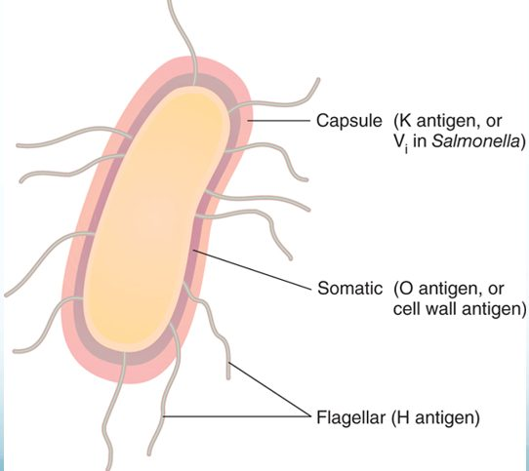
Where the H, K and O antigens are. The serotype names in 14.11 (O157:H7) are read off these. Source: Lecture 14 Dr. Webster Gram Negative Bacilli of Medical Importance.pptx, Slide 53.

14.11 · Objective 1 — Escherichia coli and its four pathotypes
Escherichia coli is the common aerobic, non-fastidious bacterium of the gut, but not the most prevalent: the anaerobic Bacteroides and Bifidobacterium are. Of about 150 strains, some have developed virulence through plasmid transfer; others are opportunists.
★ PROFESSOR EMPHASIS
★ Lecturer emphasized — “four different strains of E. coli that you need to know”
“Hint, hint, hint, hint” [1:04:18]: the four pathotypes below, each with its mechanism, disease, source, test and prevention.

The diarrheal strains are acquired from fecally contaminated food and water (the entry-and-exit diagram of slide 56). Each of the four pathotypes, row by row:
Pathotype | How it causes disease | Disease | Source and diagnosis | Treatment and prevention
Enterotoxigenic Escherichia coli (ETEC) | Enterotoxigenic Escherichia coli: heat-labile and heat-stable toxins promote secretion of fluid and electrolytes by the intestinal epithelium; fimbriae adhere it to the small intestine | Traveler’s diarrhea (most cases): diarrhea, cramping, low-grade to no fever | Fecally contaminated food and water | Fluid and electrolyte therapy; kaolin or Lomotil slow gut motility; bismuth salicylate counteracts the enterotoxin and is antimicrobial; fluoroquinolones
Enteroinvasive Escherichia coli (EIEC) | Enteroinvasive Escherichia coli: adhesin proteins bind the intestinal wall; no toxins, mechanical cell damage (it damages the wall mechanically, without toxins); an inflammatory disease of the large intestine, similar to shigellosis | Profuse bloody diarrhea and high fever; the very young and very old most susceptible; incubation within 24 hours | Fecally contaminated food and water; diagnosed by immunochemical tests, tissue culture and gene probes | Fluid and electrolyte therapy; trimethoprim-sulfamethoxazole
Enteropathogenic Escherichia coli (EPEC) | Enteropathogenic Escherichia coli: adheres to the intestinal lining and destroys the microvilli; inhibits uptake of vitamin B1 (thiamin) | The leading cause of the wasting form of infantile diarrhea; the greatest single cause of infant mortality worldwide | Fecally contaminated food and water | Fluid and electrolyte therapy; mecillinam, trimethoprim-sulfamethoxazole. Prevention: breast feeding
Enterohemorrhagic Escherichia coli (EHEC), O157:H7 | Enterohemorrhagic Escherichia coli, also called Shiga toxin-producing Escherichia coli: a cell wall receptor fuses with the host cell membrane, a portal for toxins including Shiga toxin (from Shigella), which binds ribosomes and disrupts protein synthesis; endothelial cells detach, platelets meet the subendothelium and coagulation starts; stress pathways release high tumor necrosis factor and interleukin 8 | Diarrhea, hemorrhagic colitis and hemolytic uremic syndrome (in 10% of cases: toxins cause apoptosis of renal tubular epithelial cells, and coagulation); gastroenteritis, dysentery, fever, acute abdominal pain | Reservoir: the intestines of cattle; contaminated beef, water and vegetables; a small infective dose (about 100 cells). Diagnosed on Rainbow agar, where O157:H7 colonies are black | Dialysis; corticosteroids “if diarrhea is not involved” (the slide’s wording); transfusions and plasmapheresis. Antibiotic therapy may exacerbate hemolytic uremic syndrome (it may worsen it)

Enterohemorrhagic outbreaks have come from a fast-food beef patty and slivered onions (2024), romaine lettuce, raw milk and cheese, and chicken wraps (2026). Rainbow agar carries chromogenic substrates for beta-galactosidase (blue/black) and beta-glucuronidase (red); O157:H7 is glucuronidase negative, so its colonies come up black. Enterohemorrhagic infection is managed with dialysis, transfusions and plasmapheresis, and antibiotic therapy is approached with caution because it may worsen hemolytic uremic syndrome.
The name O157:H7 reads the antigens of 14.10: O (somatic) antigen type 157 and H (flagellar) antigen type 7.
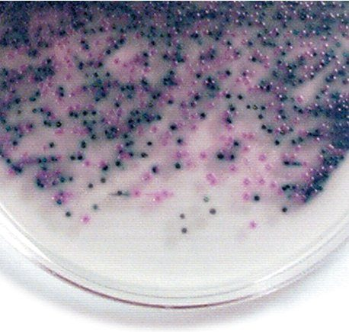
Rainbow agar. The black colonies are Escherichia coli O157:H7: galactosidase gives the blue-black, and O157:H7 lacks the glucuronidase that would add red. Source: Lecture 14 Dr. Webster Gram Negative Bacilli of Medical Importance.pptx, Slide 64.
Escherichia coli outside the gut. It causes most urinary tract infections, more frequently in women and in catheterized patients; also neonatal meningitis, pneumonia, septicemia, wound infections and complications of invasive procedures. The coliform count is the indicator of fecal contamination in water.

14.12 · Objective 1 — The other coliforms
Clinically important mainly as opportunists and for antibiotic resistance.
Organism | Distinguishing feature | Infections
Klebsiella pneumoniae | A normal inhabitant of the respiratory tract; a large capsule | Nosocomial pneumonia, meningitis, bacteremia, wound infections, urinary tract infections
Enterobacter species | Serious if in the bloodstream | Urinary tract and surgical wound infections; spinal fluid, sputum, blood
Citrobacter species | — | Opportunistic urinary tract infections and bacteremia
Serratia marcescens | Red pigment, prodigiosin | Pneumonia in chronic alcoholics; burn and wound infections; urinary tract infections (often asymptomatic, after surgery or instrumentation); septicemia and meningitis, particularly in the immunocompromised

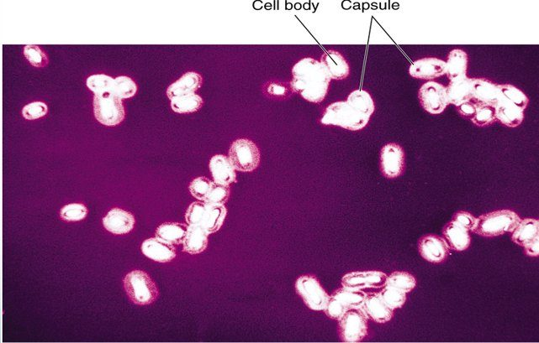
The Klebsiella pneumoniae capsule : each cell body sits in a wide clear halo. Source: Lecture 14 Dr. Webster Gram Negative Bacilli of Medical Importance.pptx, Slide 67.
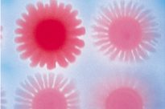
Serratia marcescens : the red of prodigiosin. Source: Lecture 14 Dr. Webster Gram Negative Bacilli of Medical Importance.pptx, Slide 68.

14.13 · Objective 1 — Proteus and its relatives
The noncoliform, lactose-negative enterics fall into opportunists (Proteus, Morganella, Providencia) and true pathogens with true virulence factors, not normal flora (Salmonella, Shigella). The opportunists are ordinarily harmless saprobes in soil, manure, sewage and polluted water and commensals of humans and animals, often resistant to antibiotics.
Organism | Features | Infections
Proteus | Highly motile, with peritrichous flagella; diagnostic wavelike, swarming growth (Proteus vulgaris); most respond to ampicillin and cephalosporins | Urinary tract and wound infections, pneumonia, septicemia, infant diarrhea; nosocomial infections; related to bladder and kidney stones (an association, not a proven cause); associated with Crohn’s disease
Providencia species | Multiple animal reservoirs; almost always resistant to tetracyclines, older penicillins and cephalosporins | Nosocomial infections; urinary tract infections with catheters; gastroenteritis
Morganella morganii | Multidrug resistant, though most strains are naturally susceptible to several drug classes | Nosocomial; similar to Proteus: urinary tract and wound infections

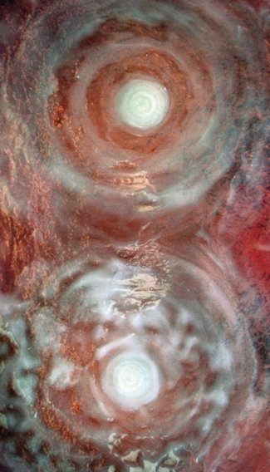
Swarming : Proteus vulgaris moves out across the plate in waves, the rings its diagnostic growth pattern. Source: Lecture 14 Dr. Webster Gram Negative Bacilli of Medical Importance.pptx, Slide 71.
Proteus vulgaris is diagnosed on the plate by its wavelike, swarming growth: highly motile on its peritrichous flagella, it spreads across the agar in waves.

14.14 · Objective 1 — Salmonella : typhoid and the salmonelloses
Salmonella typhi causes typhoid fever and Salmonella paratyphi paratyphoid fever, the most serious diseases of the genus.
Heading | Salmonella typhi (S. enterica serotype typhi) and S. paratyphi
Significance | The most serious pathogens of the genus: typhoid fever and paratyphoid fever
Host | Humans are the exclusive hosts
Traits | Flagellated; survive outside the host; resistant to chemicals: bile and dyes; do not lose virulence on cultivation
Transmission | Ingestion of fecally contaminated food or water; occasionally close personal contact. “Boil it, cook it, peel it, or forget it.”
Carriers | Asymptomatic carriers; some chronic carriers shed bacilli from the gallbladder
Pathogenesis | Bacilli adhere to the small intestine and cause an invasive diarrhea that leads to septicemia; carried to the liver and spleen; the intestinal wall can ulcerate and perforate
Manifestations | Sustained fever of 103–104 degrees; a rash of rose-colored spots; weakness, stomach pains, loss of appetite
Treatment | Chronic infections: chloramphenicol or trimethoprim-sulfamethoxazole
Prevention | Two vaccines for temporary protection: oral (4 doses) and injected (1 dose)

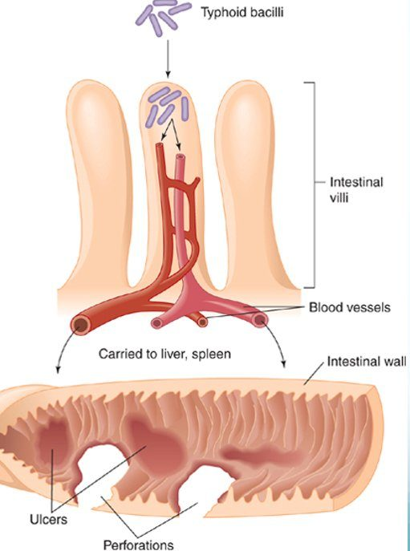
The typhoid route : into a villus of the small intestine, into the blood, on to the liver and spleen; the wall can ulcerate and perforate. Compare Shigella , which stays in the large-bowel lining (14.15). Source: Lecture 14 Dr. Webster Gram Negative Bacilli of Medical Importance.pptx, Slide 74.
The animal salmonelloses. Salmonelloses other than typhoid fever are called enteric fevers, Salmonella food poisoning and gastroenteritis. They are usually less severe than typhoid fever but more prevalent (some 40,000–50,000 cases a year). Salmonella is normal intestinal flora in animals: S. cholerae-suis is a zoonosis of swine; S. enteritidis covers about 1,700 serotypes, all zoonotic in origin, though humans can become carriers. They are acquired by ingestion, from cattle, poultry and eggs, rodents, reptiles (pet turtles, bearded dragons), animal and dairy products, backyard flocks, and fomites contaminated with animal intestinal flora; food-borne outbreaks have come from cucumbers and charcuterie meats. Enteric fevers bring fever and septicemia; gastroenteritis brings vomiting, diarrhea and fluid loss. Treatment: chloramphenicol and trimethoprim-sulfamethoxazole.

14.15 · Objective 1 — Shigella and bacillary dysentery
Heading | Shigella
Species | S. dysenteriae, S. sonnei, S. flexneri, S. boydii
Disease | Shigellosis, an incapacitating dysentery: abdominal cramps and watery stool with blood; a few cases also develop hemolytic uremic syndrome. Half of cases are in children under 5
Transmission | Ingestion of fecally contaminated food
Pathogenesis | Invades the villi of the large intestine (it invades the large-bowel villi); does not perforate the intestine or invade the blood; enters Peyer’s patches and sets off inflammation
Toxins | Endotoxin initiates the fever; enterotoxin damages the mucosa and villi, causing bleeding and mucus secretion
Treatment | Fluid replacement; ciprofloxacin and trimethoprim-sulfamethoxazole

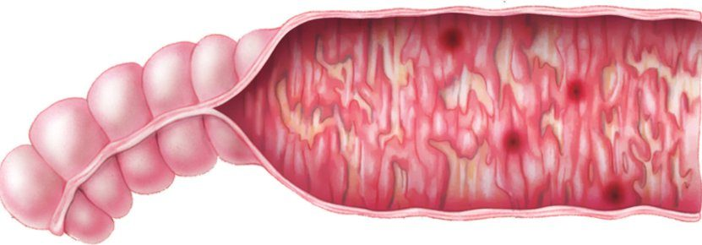
The large-intestinal mucosa in shigellosis : inflamed and bleeding in patches, the invasive pattern of 14.10. Source: Lecture 14 Dr. Webster Gram Negative Bacilli of Medical Importance.pptx, Slide 79.

14.16 · Objective 1 — The enteric yersinias
- Yersinia enterocolitica: from domestic and wild animals, fish, fruits, vegetables and water. The bacteria enter the small intestinal mucosa; some enter the lymphatics and survive in phagocytes. Inflammation of the ileum can mimic appendicitis.
- Yersinia pseudotuberculosis: an infection similar to Y. enterocolitica, with more lymph node inflammation.
- Treatment is mostly supportive (aminoglycosides and trimethoprim-sulfamethoxazole).

14.17 · Objective 1 — Yersinia pestis and plague
Heading | Yersinia pestis (nonenteric)
Morphology | Tiny Gram-negative rod with unusual bipolar staining and capsules
Virulence | Capsular and envelope proteins protect against phagocytosis and foster intracellular growth; coagulase, endotoxin, murine toxin
Reservoir | About 200 species of mammals, rodents, without causing them disease. In the United States, cases are west of the Mississippi (a handful a year)
How humans get it | Contact with wild animals (sylvatic plague), domestic or semidomestic animals (urban plague), or infected humans (rare)
The flea | The bacteria replicate in the flea’s gut; coagulase causes blood clotting that blocks the esophagus; the flea becomes ravenous and tries to bite more hosts; regurgitated material transmits the bacterium
Infective dose | Very small: 3–50 bacilli

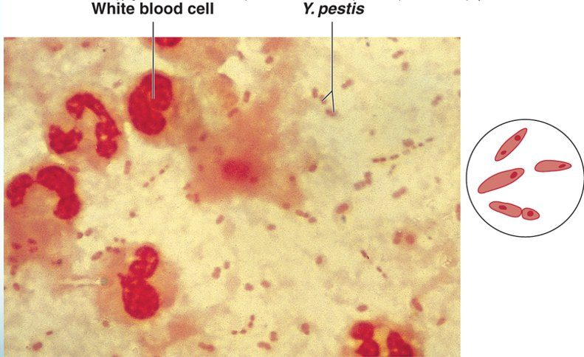
Bipolar staining. Tiny Yersinia pestis rods among white blood cells; the inset shows the stain gathered at both ends of each rod. Source: Lecture 14 Dr. Webster Gram Negative Bacilli of Medical Importance.pptx, Slide 82.
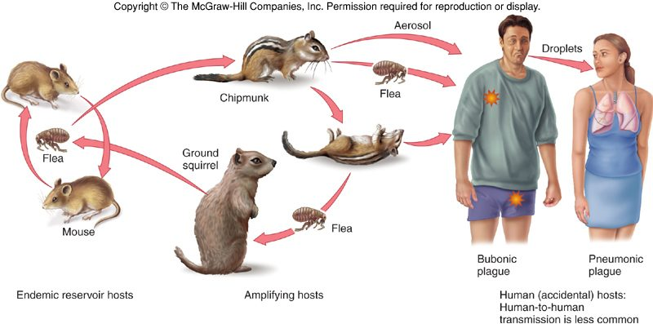
The plague cycle. Fleas keep it going among endemic reservoir rodents and amplifying hosts (chipmunks, ground squirrels); humans are accidental hosts, bubonic from a flea bite, pneumonic by aerosol and droplets. Copyright © The McGraw-Hill Companies. Source: Lecture 14 Dr. Webster Gram Negative Bacilli of Medical Importance.pptx, Slide 84.
Form of plague | What happens
Bubonic | The bacillus multiplies in the flea bite, enters the lymph, and causes necrosis and swelling of a lymph node: the bubo, a swollen, necrotic lymph node in the groin or axilla (the classic sign)
Septicemic | Progression to massive bacterial growth; virulence factors cause intravascular coagulation, subcutaneous hemorrhage and purpura that degenerates into necrosis and gangrene (the purpura turns to gangrene): the black plague
Pneumonic | Infection localized to the lungs, highly contagious by aerosol, fatal without treatment

Diagnosis, treatment, prevention. It must be diagnosed quickly: death can come within 2 days of symptoms. Diagnosis rests on history, symptoms and laboratory findings from aspiration of the buboes. Treatment: streptomycin, tetracycline or chloramphenicol. A killed or attenuated vaccine is available for military personnel, veterinarians and laboratory workers. Prevention by quarantine and control of the rodent population in human habitats. A park warning sign (slide 86) spells out the same advice: chipmunks, ground squirrels and other wild rodents may be infected; plague reaches humans by the bite of an infected flea or by handling an infected animal; protect pets from fleas, avoid animal burrows, and never touch sick or dead animals.
Plague in the world, and in our genes. Plague is endemic in Madagascar (seasonal, October to March, when rats move into homes in the wet season), with urban outbreaks of the pneumonic form in 2017 and 2021; in Russia, a laboratory worker at a Siberian anti-plague institute was hospitalized with a respiratory illness and died. The Black Death of 1346–1350 killed a large share of a population that was immunologically naive, putting strong selective pressure on genetic variants that conferred immunity, so later outbreaks killed far fewer. Deoxyribonucleic acid from that era shows that those plague-immunity variants overlap with alleles now associated with increased susceptibility to autoimmune diseases.

14.18 · Objective 1 — Pasteurella multocida
Pasteurella multocida is, with Haemophilus, one of the oxidase-positive nonenteric pathogens: a zoonotic genus, normal flora in animals. Its opportunistic infections are mostly in veterinarians, but they can come from domestic animals: Pasteurella reaches people through animal bites or scratches, which cause a local abscess that can spread to joints, bones and lymph nodes. The immunocompromised are at risk of septicemia and complications of the central nervous system and heart. Treatment: penicillin and tetracycline.

14.19 · Objective 1 — Haemophilus
Haemophilus means blood loving: tiny Gram-negative pleomorphic rods, fastidious, sensitive to drying, temperature extremes and disinfectants. None can grow on blood agar without special techniques: chocolate agar (cooked blood) is used, because they require hemin, nicotinamide adenine dinucleotide (NAD) or its phosphate (NADP): they need hemin from the cooked blood. Some species are normal colonists of the upper respiratory tract or vagina; others are virulent.
Species | Disease | Spread and who | Treatment and prevention
H. influenzae | Misnamed as the cause of the flu. Acute bacterial meningitis (fever, vomiting, stiff neck, neurological impairment), epiglottitis, otitis media, sinusitis, pneumonia, bronchitis | — | Chloramphenicol and ampicillin; vaccine: the subunit vaccine Hib (Haemophilus influenzae type b)
H. aegyptius | Conjunctivitis, pink eye | Primarily children; spread by contaminated fingers and insects | Antibiotic eyedrops
H. ducreyi | Chancroid, a sexually transmitted disease | Primarily in the tropics; primarily males | Erythromycin
H. parainfluenzae and H. aphrophilus | Infective endocarditis in congenital and rheumatic heart disease | Normal oral and nasopharyngeal flora; from routine dental procedures | Ciprofloxacin

Invasive H. influenzae disease in the United States (1994–2020) is now mostly nontypeable strains; type b, the vaccine’s target, has become the rarest (slide 99).
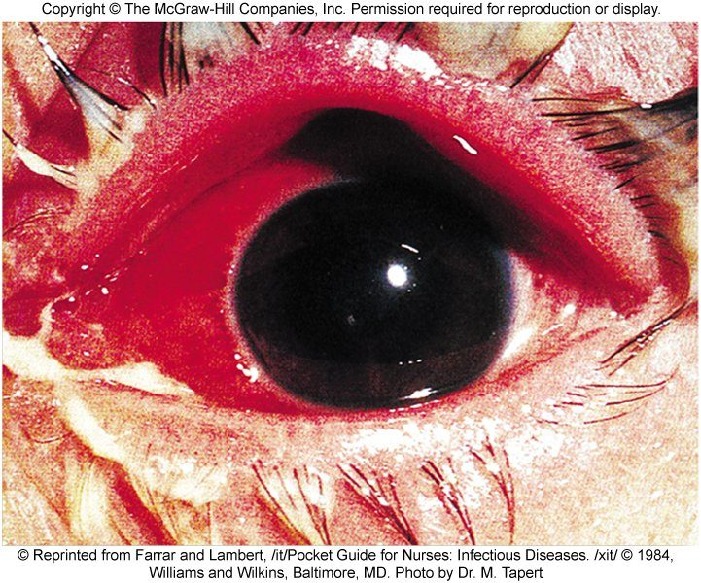
Acute conjunctivitis (pink eye) , the Haemophilus aegyptius infection of children. Copyright © The McGraw-Hill Companies. Source: Lecture 14 Dr. Webster Gram Negative Bacilli of Medical Importance.pptx, Slide 101.

14.20 · Objective 2 — Modes of transmission
Organism | How humans acquire it
Pseudomonas aeruginosa | Soil and water; nosocomial, from contaminated ventilators, intravenous solutions and anesthesia equipment (biofilms); contact lenses (corneal ulcers), water (swimmer’s ear)
Burkholderia pseudomallei | Tropical soil and water, by penetrating injury or inhalation
Acinetobacter baumannii | Nosocomial and community; months on fomites; traumatic and combat wounds
Stenotrophomonas maltophilia | Biofilms on disinfectants, dialysis and respiratory equipment, water dispensers and catheters
Brucella | Zoonosis: animal handling and slaughtering (blood, urine, placentas) or unpasteurized dairy; through damaged skin or mucous membranes; human-to-human rare
Francisella tularensis | Infected animals (rabbits), water and dust, or vector bites
Bordetella pertussis | From apparently healthy carriers by direct contact or inhaled aerosols
Legionella | Aerosols from water systems (cooling towers, spas, fountains, air conditioning, vegetable sprayers)
Enterics in hospitals | Soap dishes, sinks, catheters, tracheal cannulas
Escherichia coli diarrheal strains | Fecally contaminated food and water; O157:H7 from cattle via beef, water and vegetables
Escherichia coli urinary tract infection | Women; catheterized patients
Providencia | Multiple animal reservoirs; catheters
Salmonella typhi | Humans only: fecally contaminated food or water, occasionally close contact; chronic gallbladder carriers
Animal salmonelloses | Ingestion from cattle, poultry and eggs, rodents, reptiles, dairy, backyard flocks, contaminated fomites
Shigella | Ingestion of fecally contaminated food
Yersinia enterocolitica | Animals, fish, fruits, vegetables, water
Yersinia pestis | Flea bite (regurgitation by a blocked flea); handling infected animals; aerosol in pneumonic plague; sylvatic (wild animals) or urban (domestic animals)
Pasteurella multocida | Animal bites or scratches
Haemophilus | H. aegyptius: fingers and insects. H. ducreyi: sexual. H. parainfluenzae and H. aphrophilus: own oral flora, during dental procedures

14.21 · Where the slides disagree, and where current practice differs
The slides are what is taught and tested; where they disagree with each other, the point is not keyed in the quizzes. Notes:
- Serratia and Hafnia: coliform or not? Slide 50 lists both among the coliforms (lactose fermenters), and slide 68 calls Serratia a coliform; Table 20.1 (slide 12) and the biochemical tree (slide 47) put both on the non-lactose-fermenting branch. (Serratia is in fact a slow, late lactose fermenter.) In the recording she calls Serratia “also a coliform” [1:23:06], as slides 50 and 68 do, but the scheme of slide 12 still disagrees, so no question asks their lactose status.
- Which Haemophilus causes childhood meningitis? Slide 97 names H. parainfluenzae and H. ducreyi as the virulent species “responsible for childhood meningitis, and chancroid”; slide 98 gives meningitis to H. influenzae, and slide 100 calls H. parainfluenzae normal oral flora that causes endocarditis. Go by slides 98 and 100. Reading slide 97 aloud, she named no species: some species are normal flora, “and then other species are responsible for childhood meningitis and chancroid” [2:00:50], and she then gave meningitis to H. influenzae [2:01:23].
- “Motile, oxidase positive” is given to Burkholderia, Acinetobacter and Stenotrophomonas together (slide 21). In fact Acinetobacter is nonmotile and oxidase negative, and Lecture 9 taught Acinetobacter baumannii among the Gram-negative cocci (it is a coccobacillus). Not keyed; their shared traits are keyed as obligate aerobes that do not ferment sugars.
- The World Health Organization list (slide 17). The 2017 list put carbapenem-resistant Pseudomonas aeruginosa among the critical pathogens with Acinetobacter baumannii and the resistant Enterobacteriaceae; the 2024 update moved it to the high-priority group. Not keyed.
- Boostrix (slide 31) is given for ages 10–18 on the slide; it is licensed from age 10 through adulthood, including pregnancy. Not keyed.
- Drug lists. Several treatment lines reflect older practice (chloramphenicol for typhoid and for H. influenzae meningitis, erythromycin with rifampin for Legionella, streptomycin for plague); current regimens differ. Doses on slide 56 are not reproduced. Which antibiotic treats what is not asked in the quizzes; the non-drug methods (fluids and electrolytes, dialysis and plasmapheresis, vaccines, breast feeding, quarantine, combination therapy for multidrug resistance) are.
- Spellings. The deck’s “Acinetobacter baumanii” is Acinetobacter baumannii; “Salmonella typhhi” Salmonella typhi; “Mecillianam” mecillinam; “sulfatrimethoprim” and “Sulfamethoprim” are trimethoprim-sulfamethoxazole.
Source: Gram Negative Bacilli of Medical Importance (Lecture 14 Dr. Webster Gram Negative Bacilli of Medical Importance.pptx), Slides 1–101, and the PAJ 5200 syllabus instructional objectives.

15 · Fungi of Medical Importance
Dr. Fair · Lecture 15 · 30 October 2026
INSTRUCTIONAL OBJECTIVES
- Compare and contrast the morphology, medium, laboratory tests, biochemical reactions, diseases, clinical manifestations, methods of treatment, and prevention of fungi of medical importance.
- Describe the modes of transmission by which humans acquire fungi of medical importance.

NOTE
Two questions sort every fungus here. Can it infect a healthy person? If yes it is a true (primary) pathogen, and the four true pathogens (Histoplasma, Coccidioides, Blastomyces, Paracoccidioides) are thermally dimorphic: a mold in the soil, a yeast in the body. If no, it is an opportunist that needs impaired defenses (Candida, Aspergillus, Cryptococcus, Pneumocystis, the Zygomycota, Fusarium). How deep does it go? Systemic (inhaled spores, lungs first), subcutaneous (a puncture wound: Sporothrix), cutaneous (keratin only: the dermatophytes and the tineas) or superficial (the hair or the top of the skin: tinea versicolor and the piedras). The syllabus points to its Appendix 2 list of seven organisms for this lecture: Candida, Aspergillus, Cryptococcus, Histoplasma, Blastomyces, Coccidioides and Paracoccidioides. Objective 1 is answered topic by topic; objective 2 (how people acquire each one) is drawn together in 15.22.

★ PROFESSOR EMPHASIS
★ From the lecture recording — 30 October 2026
Not read yet. This lecture was recorded on 30 October and the recording is being transcribed (ours, plus Notability’s own transcript as a second opinion). Until it has been read, this section is built from the slides alone: the quizzes are weighted by slide count, and the only emphasis marked is the slides’ own (“Focus on the Latin names for each body part/region” on slide 43, 15.13). When the recording has been read, this box will carry what Dr. Fair stressed, what she said to skip, and any correction of a slide.

15.1 · Objective 1 — True and opportunistic fungal pathogens
Molds and yeasts are widely distributed in air, dust, fomites and the normal flora of humans, plants and animals. Humans are relatively resistant to fungal infections as long as the immune system is competent; immunocompromised status is the serious consideration throughout this lecture. Fungi are relatively nonpathogenic: of about 100,000 fungal species only about 300 (0.3%) have been linked to disease in humans and animals. But fungi are the most common plant pathogens (potato blights, infected grape crops and fruit trees), which can cause huge socio-economic losses such as the potato famines in Ireland and Eastern Europe. Human mycoses (“myco” = fungi) are caused by true fungal pathogens and by opportunistic pathogens.
Kind of pathogen | Definition | Key adaptation | Levels of disease | Immunity afterwards
True (primary) fungal pathogen | Can invade and grow in a healthy host | Switching from hyphal cells to yeast cells (multicellular to unicellular) with temperature: thermal dimorphism (15.2) | May cause systemic, subcutaneous, cutaneous and superficial mycoses | Long-term immunity can develop against a few true fungal pathogens
Opportunistic fungal pathogen | Has little or no virulence of its own; the host defenses must be impaired (human immunodeficiency virus infection, cancer, diabetes, chronic obstructive pulmonary disease, autoimmune disorder, nosocomial infection) | Few, if any, virulence factors; infection usually starts in an immunocompromised host. Consider predisposing factors: primary illness, corticosteroids, diabetes, cancer | From superficial colonization of external tissues to potentially fatal systemic disease of one or more organ systems | Reinfection is highly likely (think of recurring vaginal yeast infection or foot fungus)

True (primary) fungal pathogen. Its defining ability is invading and growing in a healthy host; an opportunist, by contrast, has little or no virulence of its own and needs impaired host defenses.
Opportunistic mycosis. A fungus with few, if any, virulence factors that infects a host weakened by corticosteroids is an opportunistic mycosis: these fungi usually start infection in immunocompromised hosts.
An emerging medical concern. Mycoses account for about 10% of all nosocomial infections, and the proportion is rising. Dermatophytes (residents of human and animal skin) may be undergoing a gradual transformation to become true pathogens.

15.2 · Objective 1 — Thermal dimorphism
The most striking adaptation of a true pathogen to survival and growth in the human host is the ability to switch from hyphal cells to yeast cells, from multicellular to unicellular forms, with the corresponding change in temperature. Thermal dimorphism: the fungus grows as a mold (multicellular) at 30 °C and as a yeast (unicellular) at 37 °C, which is human body temperature.
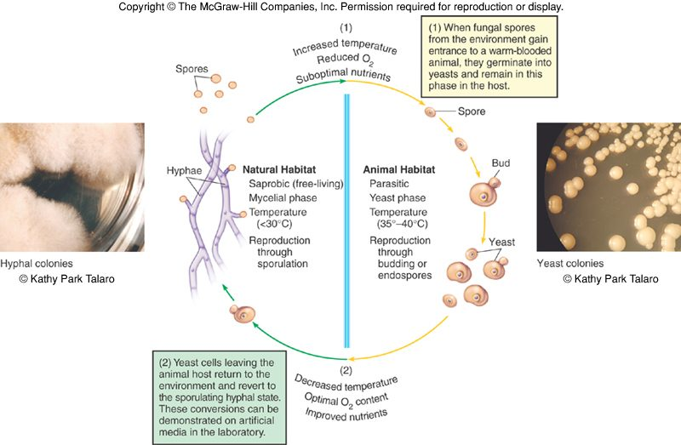
Two habitats, two forms. Natural habitat: saprobic (free-living), mycelial phase, below 30 °C, reproduces by sporulation . Animal habitat: parasitic, yeast phase, 35–40 °C, reproduces by budding or endospores . (1) Spores that enter a warm-blooded animal (increased temperature, reduced oxygen, suboptimal nutrients) germinate into yeasts and stay yeasts in the host. (2) Yeast cells that leave the host (decreased temperature, optimal oxygen, improved nutrients) revert to the sporulating hyphal state; these conversions can be shown on artificial media in the laboratory. Copyright © The McGraw-Hill Companies. Source: PAJ5200.Fungi of Medical importance.pptx, Slide 6.
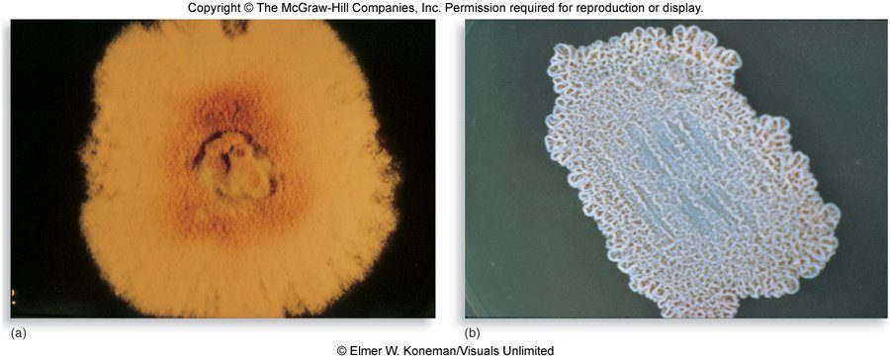
The same fungus at two temperatures. Histoplasma capsulatum grown below 35 °C (left, the mold) and at 37 °C (right, the yeast). © Elmer W. Koneman/Visuals Unlimited. Copyright © The McGraw-Hill Companies. Source: PAJ5200.Fungi of Medical importance.pptx, Slide 27.
Two colonies, one fungus. One fungus forming a fuzzy, mold-like colony below 35 C and a yeast-like colony at 37 C, human body temperature, demonstrates thermal dimorphism.

15.3 · Objective 1 — The fungal priority pathogens list
The World Health Organization announced its first-ever fungal priority pathogens list in October 2022, to complement its bacterial priority pathogens list of 2017. Worldwide, drug-resistant bacteria directly cause over 1 million deaths a year and contribute to another 5 million; drug-resistant fungi are rapidly becoming a concern. With closer attention to nosocomial and secondary infections, invasive fungal diseases have been found to be increasing, especially among immunocompromised populations. The catch: fungal infections get little attention compared with bacterial or viral infections, and so less money for research and development (detection, diagnosis, treatment, new drugs).
Priority | Fungi on the list
Critical | Cryptococcus neoformans (“the number one critical fungal pathogen”, slide 56), Aspergillus fumigatus (number three, slide 60), Candida albicans, Candida auris
High | Other Candida species, eumycetoma causative agents, Fusarium species, Histoplasma species, Mucorales (mucormycosis opportunists)
Medium | Coccidioides, Cryptococcus gattii, Pneumocystis jirovecii, Paracoccidioides species

One tier above Coccidioides. Coccidioides is in the medium priority group; Histoplasma species are in the high priority group, one tier above.

15.4 · Objective 1 — Epidemiology, pathogenesis and host defense
- Most fungal pathogens do not require a host to complete their life cycles, and these infections are generally not communicable to other persons.
- The exceptions: dermatophytes (literally “skin plants”) and Candida species naturally inhabit the human body and are transmissible from person to person, or by fomites such as shared exercise equipment.
- True fungal pathogens are distributed in predictable geographical patterns, coinciding with climate and soil requirements (the map in 15.7).
- Dermatophytoses are the most prevalent fungal diseases, and many cases go undiagnosed or are misdiagnosed (for example as skin-related allergies or autoimmune disorders).
Type of mycosis | Portal of entry (slide 14)
Primary (systemic) mycoses | Respiratory: spores inhaled from the air
Subcutaneous | Inoculated into skin or nails: trauma
Cutaneous and superficial | Contamination of the skin or hair surface

Virulence factors: thermal dimorphism, toxin-like substances, capsules and adhesion factors, hydrolytic enzymes, inflammatory stimulants.
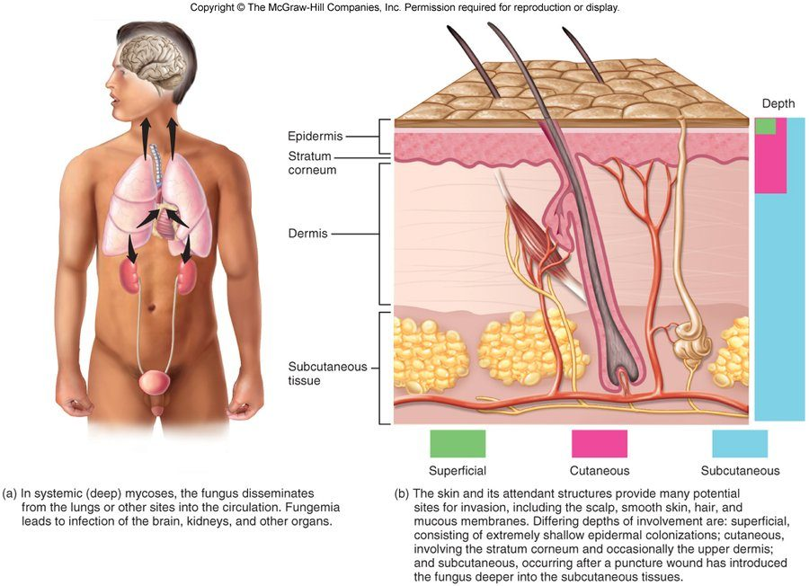
Levels of invasion. (a) In systemic (deep) mycoses the fungus disseminates from the lungs or other sites into the circulation; fungemia leads to infection of the brain, kidneys and other organs. (b) Superficial : extremely shallow epidermal colonization. Cutaneous : the stratum corneum and occasionally the upper dermis. Subcutaneous : after a puncture wound has introduced the fungus deeper, into the subcutaneous tissues. Copyright © The McGraw-Hill Companies. Source: PAJ5200.Fungi of Medical importance.pptx, Slide 23.

Host defense
The main antifungal defenses are the integrity of the skin, mucous membranes and intact respiratory cilia. The most important defenses are cell-mediated immunity (T cells and their cytokines), phagocytosis and inflammation. Long-term immunity can develop against only a few true fungal pathogens, not the opportunists: reinfection is highly likely with opportunistic fungi (the repeated “episodes” of vaginal yeast infection or foot fungus).

15.5 · Objective 1 — Diagnosis
Diagnosis and identification need microscopic examination of stained specimens, culture on selective and enriched media, and specific biochemical or serological tests. Sabouraud dextrose agar is commonly used, with chemicals added to inhibit bacterial growth; its fairly low pH inhibits most bacteria, but not fungi.
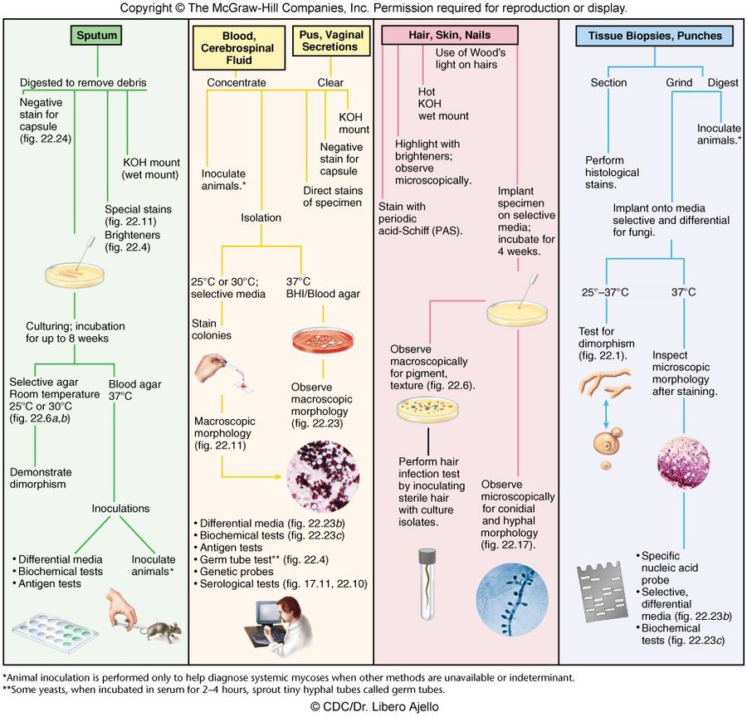
Identifying fungal isolates (the flowchart). Sputum : digested to remove debris; negative stain for a capsule, potassium hydroxide wet mount, special stains and brighteners; culture for up to 8 weeks on selective agar at room temperature (25 or 30 °C) and blood agar at 37 °C to demonstrate dimorphism ; then differential media, biochemical and antigen tests or animal inoculation. Blood, cerebrospinal fluid, pus, vaginal secretions : potassium hydroxide mount, negative stain for a capsule, direct stains; culture at 25 or 30 °C on selective media and 37 °C on brain heart infusion or blood agar; then differential media, biochemical and antigen tests, the germ tube test , genetic probes, serological tests. Hair, skin, nails : Wood’s light on hairs , hot potassium hydroxide wet mount, brighteners, periodic acid-Schiff stain; implant on selective media and incubate for 4 weeks; hair infection test with sterile hair. Tissue biopsies : histological stains; culture at 25–37 °C and at 37 °C to test for dimorphism; specific nucleic acid probe. Footnotes: animal inoculation is done only to help diagnose systemic mycoses when other methods are unavailable or indeterminate; some yeasts, incubated in serum for 2–4 hours, sprout tiny hyphal tubes called germ tubes . Copyright © The McGraw-Hill Companies. Source: PAJ5200.Fungi of Medical importance.pptx, Slide 17.
Hair, skin and nail specimens. The identification pathway applies examination under Wood's light directly to the hairs, alongside a hot potassium hydroxide wet mount, brighteners and periodic acid-Schiff staining.
Germ tube test. Some yeasts, when incubated in serum for 2 to 4 hours, sprout tiny hyphal tubes called germ tubes; the germ tube test sits among the identification tests for isolates.
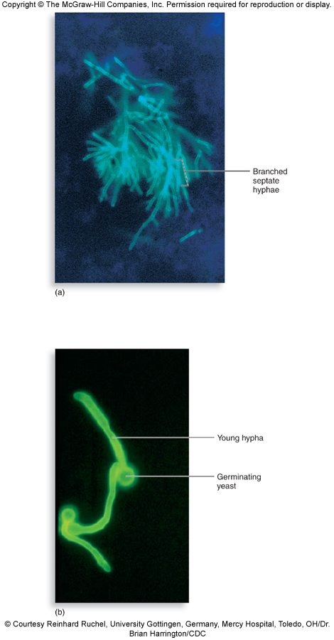
Dyes amplify fungal elements. Above, Aspergillus from a sputum specimen: branched septate hyphae . Below, germinating Candida albicans : a young hypha growing from a germinating yeast (an oral or vaginal swab could give this). Treating such a slide with dilute potassium hydroxide lyses the human epithelial cells and leaves the fungal cells intact, because fungi have a thicker cell wall that human cells lack. Copyright © The McGraw-Hill Companies. Source: PAJ5200.Fungi of Medical importance.pptx, Slide 18.

15.6 · Objective 1 — Control and amphotericin B
- Immunization is typically ineffective for preventing fungal infections, because reinfection is exceedingly common.
- Antifungal drugs: amphotericin B, flucytosine, azoles and nystatin.
- In some cases surgical removal of damaged tissue is necessary.
- Prevention is essentially limited to high-quality respirator masks and protective clothing and hygiene, to reduce contact with fungal spores.
Amphotericin B | Slide 20
Standing | The drug of choice for many fungal infections: highly toxic and often expensive
Source | Produced by a soil bacterium of the genus Streptomyces; it attacks fungal cells, which are eukaryotic
Mechanism | Forms complexes with fungal cell membrane lipids, causing openings and seepage of cytoplasmic ions
Why it is toxic | Not selective enough to attack only fungi: fungi and humans are both eukaryotes
Side effects | Fatigue, weakness, fever and arrhythmia; sometimes known as “ampho-terrible”
Routes | Called versatile on the slide (topical, oral, intramuscular or intravenous; see 15.23)

Why amphotericin B harms the patient's own cells. It complexes with cell membrane lipids, and because fungi and humans are both eukaryotes the action is not selective enough to attack only fungi; fatigue, weakness, fever and arrhythmia are its potentially serious side effects.

15.7 · Objective 1 — Systemic mycoses: the true fungal pathogens
Mycoses are organized by type, level of infection and degree of pathogenicity (15.1). The systemic infections of the true pathogens share a pattern (slide 24):
- Each true fungal pathogen is restricted to certain endemic regions of the world.
- Infection occurs when soil or other matter (such as animal waste) containing the conidia is disturbed.
- The spores germinate in the lungs, producing yeast or yeast-like cells: thermal dimorphism at work.
- Infection can become systemic in some hosts; spores may also be inoculated into broken skin.
- The diseases of the true fungal pathogens can result in immunity in a competent host.
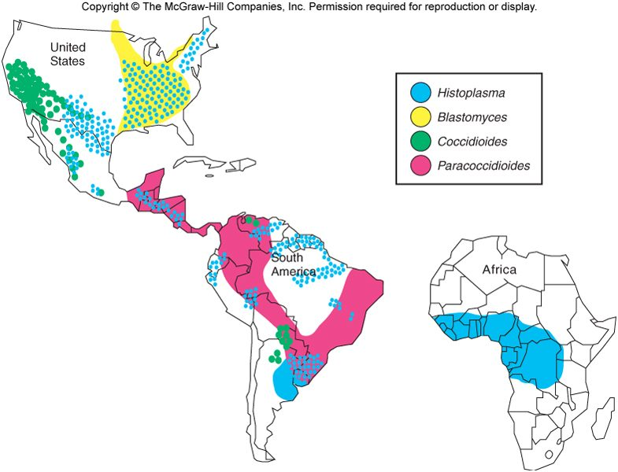
Where the four true fungal pathogens live (shown on slides 13, 25, 29, 32 and 36). Blue, Histoplasma : eastern and central United States, Latin America and Africa. Yellow, Blastomyces : midwestern and southeastern United States and southern Canada. Green, Coccidioides : the southwestern United States and Mexico. Pink, Paracoccidioides : Central and South America. Copyright © The McGraw-Hill Companies. Source: PAJ5200.Fungi of Medical importance.pptx, Slide 13.
Pathogen | Disease (nickname) | Where | Soil | Signature | Treatment on the slide
Histoplasma capsulatum | Histoplasmosis, “Ohio Valley fever” | Eastern and central United States; worldwide; Latin America, Africa | Moist, high-nitrogen soil, bird and bat guano | The most common true fungal pathogen; not person to person | Amphotericin B and azoles
Coccidioides immitis | Coccidioidomycosis, “Valley fever” | Southwestern United States, Mexico, Central and South America | Alkaline, salty soils of semiarid, hot climates | Block-like arthroconidia; spherules with endospores in the lungs | Amphotericin B; most cases need no treatment
Blastomyces dermatitidis | North American blastomycosis | Midwestern and southeastern United States, southern Canada | Rich organic matter: forest soil, decaying wood, animal manure | May be mistaken for lung cancer on chest X-ray | Amphotericin B
Paracoccidioides brasiliensis | Paracoccidioidomycosis | Central and South America (Brazil, Colombia, Venezuela, Argentina, Paraguay) | Cool, humid soils | The rarest primary mycosis | Ketoconazole, amphotericin B, sulfa drugs

15.8 · Objective 1 — Histoplasma capsulatum : histoplasmosis, “Ohio Valley fever”
- The most common true fungal pathogen; causes histoplasmosis. Thermally dimorphic (the two colonies in 15.2).
- “Ohio Valley fever” is histoplasmosis, caused by Histoplasma capsulatum, the most common true fungal pathogen.
- Distributed worldwide; known in the eastern and central regions of the United States, and now recognized as endemic in parts of Latin America and Africa.
- Grows in moist soil with high nitrogen content, especially soil containing bird and bat guano.
- Not caught from another person. Histoplasmosis is not transmitted person to person, so a spouse cannot catch it from him; people acquire it by inhaling conidia from moist soil enriched with bird or bat guano.
- Inhaled conidia produce a primary pulmonary infection that may progress to systemic involvement of a variety of organs, the central nervous system, and chronic lung disease. It is NOT transmitted person to person.
- Treatment: amphotericin B and azoles are common options.
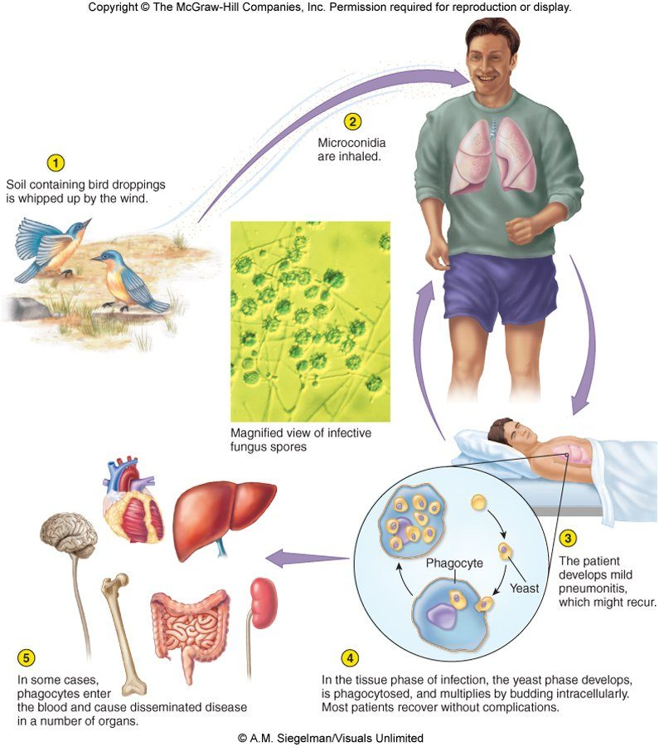
Events in histoplasmosis. (1) Soil containing bird droppings is whipped up by the wind. (2) Microconidia are inhaled. (3) The patient develops a mild pneumonitis, which might recur . (4) In the tissue phase the yeast phase develops, is phagocytosed and multiplies by budding intracellularly ; most patients recover without complications . (5) In some cases phagocytes enter the blood and cause disseminated disease in a number of organs. © A.M. Siegelman/Visuals Unlimited. Copyright © The McGraw-Hill Companies. Source: PAJ5200.Fungi of Medical importance.pptx, Slide 28.

15.9 · Objective 1 — Coccidioides immitis : coccidioidomycosis, “Valley fever”
- Mainly in the southwestern United States, extending to Mexico and Central and South America. Exposure comes with farming, road construction and repair, archaeological digs, landslides and dust storms. It remains dormant in winter and spring.
- Significant risk factors: people of African or African-American descent, increasing age (over 40–60 years), and environmental or occupational exposure to dust and soil.
- Distinctive morphology: block-like arthroconidia in the free-living stage, and spherules containing endospores in the lungs.
- Lives in alkaline, salty soils in semiarid, hot climates; its spread is greatly enhanced by cycles of drought and heavy rain, followed by windstorms.
- Arthrospores inhaled from dust create spherules and can form nodules in the lungs.
- Prevention: oiling roads, planting to minimize erosion, and dust masks to reduce inhalation of spores.
- Keeping down dust. Coccidioides arthrospores are inhaled from dust, so prevention targets dust: oiling roads to keep down dust, planting to minimize erosion and using dust masks.
- Treatment: amphotericin B is the most common option, but most cases do not require any treatment at all.
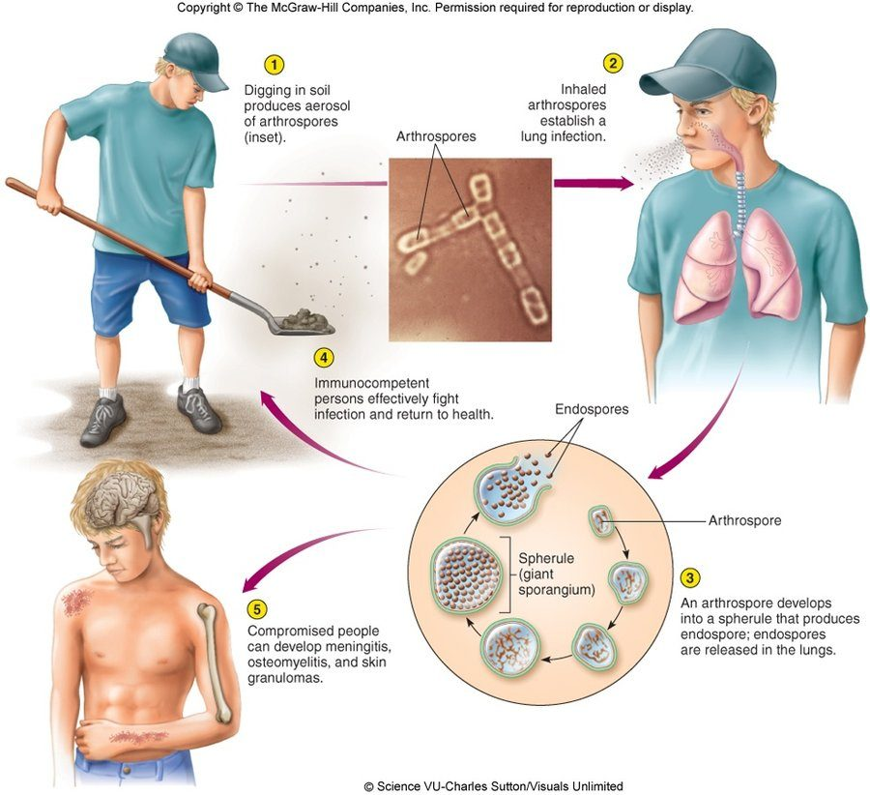
Events in coccidioidomycosis. (1) Digging in soil produces an aerosol of arthrospores. (2) Inhaled arthrospores establish a lung infection. (3) An arthrospore develops into a spherule (giant sporangium) that produces endospores, released in the lungs. (4) Immunocompetent persons fight the infection and return to health. (5) Compromised people can develop meningitis, osteomyelitis and skin granulomas. © Science VU-Charles Sutton/Visuals Unlimited. Copyright © The McGraw-Hill Companies. Source: PAJ5200.Fungi of Medical importance.pptx, Slide 31.

15.10 · Objective 1 — Blastomyces dermatitidis : North American blastomycosis
- A dimorphic fungus that inhabits rich organic matter: forest soil, decaying wood, animal manure.
- Free-living, mainly in the soil of a large section of the midwestern and southeastern United States, and in southern Canada; dormant in warm, dry weather, then sporulates in colder, wetter weather. Also reported in South and Central America, Africa and the Middle East.
- Inhaled conidia (10–100) convert to yeasts and multiply in the lungs; the infection may be mistaken for lung cancer on a chest X-ray.
- Acquiring Blastomyces dermatitidis. People acquire it by inhaling its conidia when the soil is disturbed; the inhaled conidia convert to yeasts and multiply in the lungs, causing cough, chest pain and fever.
- Blastomyces in the lungs. Blastomyces is a dimorphic fungus, free-living in soil; its inhaled conidia convert to multiplying yeast cells in the lungs.
- Symptoms: cough, chest pain and fever, in humans, dogs, cats and horses.
- Chronic cutaneous nodules, with later bone and nervous system complications.
- Treatment: amphotericin B is the most common option.
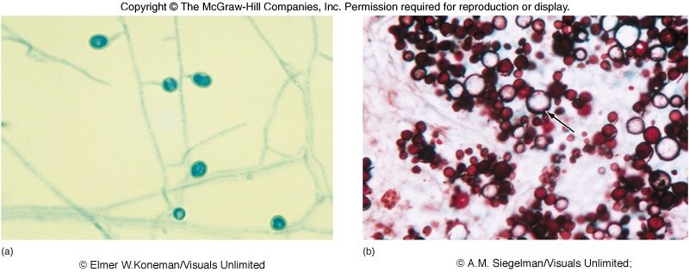
The dimorphic nature of Blastomyces dermatitidis : (a) the mold form, hyphae with conidia; (b) the yeast form in tissue. Copyright © The McGraw-Hill Companies. Source: PAJ5200.Fungi of Medical importance.pptx, Slide 34.
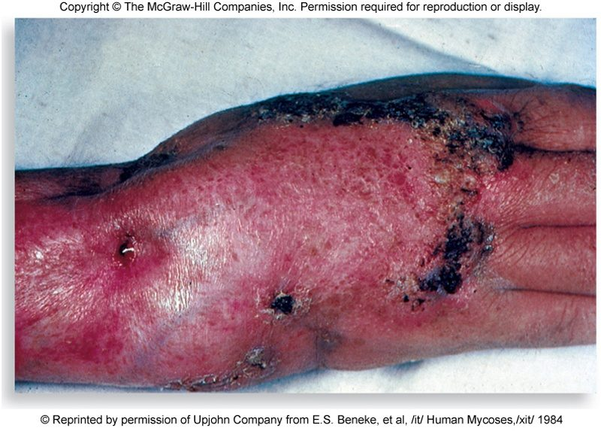
Cutaneous blastomycosis of the hand and wrist. Copyright © The McGraw-Hill Companies. Source: PAJ5200.Fungi of Medical importance.pptx, Slide 35.

15.11 · Objective 1 — Paracoccidioides brasiliensis : paracoccidioidomycosis
- Endemic in Central and South America, mainly the cool, humid soils of Brazil, Colombia, Venezuela, Argentina and Paraguay; the rarest of the primary mycoses. Most studies in the World Health Organization report were among human immunodeficiency virus-positive patients in Brazil.
- Lung or skin infection occurs through inhalation or inoculation of spores, respectively.
- Most at risk: rural farm workers and harvesters, where poor nutrition is a predisposing factor; male, over 40 years old.
- Paracoccidioidomycosis risk profile. Rural farm workers and harvesters are most at risk; poor nutrition (a poorly nourished worker) is a predisposing factor, and male sex and age over 40 add to the risk.
- Systemic disease is not common; these are usually mild, self-limiting infections.
- The rarest primary mycosis. Paracoccidioidomycosis is the rarest of the primary mycoses; systemic disease is not common, and infections are usually mild and self-limiting.
- Treatment: ketoconazole, amphotericin B and sulfa drugs are commonly used.

15.12 · Objective 1 — Subcutaneous mycoses: Sporothrix schenckii
Subcutaneous mycoses occur when fungi are transferred directly into traumatized skin and invade the damaged site. Most species in this group are greatly inhibited by the higher temperatures of the blood and viscera, so they rarely disseminate through the body. These diseases are progressive and may destroy skin and underlying tissue.
- Sporotrichosis, “rose-gardener’s disease”, usually comes from a puncture wound: a thorn, wood, bare roots.
- A very common saprobic fungus (one that derives its nutrition from dead or decaying matter) that decomposes plant matter in soil. Garden center workers, plant nurseries and people who handle pine straw or hay bales may be at risk.
- Saprobic. A saprobe feeds on dead or decaying matter, deriving its nutrition from it; Sporothrix schenckii is a very common saprobic fungus that decomposes plant matter in soil.
- Infects appendages and lungs (humans, horses, dogs, cats and mules; in animals it is often seen in the feet, claws or hooves).
- Treatment: heat packs and/or super-saturated potassium iodide; systemic infections with amphotericin B and/or itraconazole.
- The lymphocutaneous variety: contaminated plant material penetrates the skin, the pathogen forms a nodule, then spreads to nearby lymph nodes.
- Thorn puncture, nodule, then a line of lesions up the forearm. This is lymphocutaneous sporotrichosis: Sporothrix schenckii forms a nodule where contaminated plant material penetrated the skin and spreads to nearby lymph nodes.
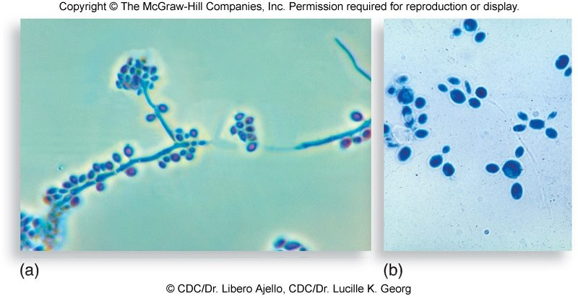
The microscopic morphology of Sporothrix schenckii : (a) hyphae with clusters of conidia; (b) yeast cells. © CDC/Dr. Libero Ajello, CDC/Dr. Lucille K. Georg. Copyright © The McGraw-Hill Companies. Source: PAJ5200.Fungi of Medical importance.pptx, Slide 40.
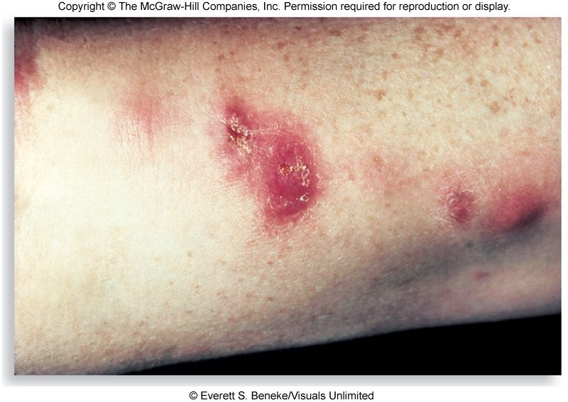
Lymphocutaneous sporotrichosis : nodules along the arm. © Everett S. Beneke/Visuals Unlimited. Copyright © The McGraw-Hill Companies. Source: PAJ5200.Fungi of Medical importance.pptx, Slide 41.

15.13 · Objective 1 — Cutaneous mycoses: the dermatophytes
- Infections strictly confined to keratinized epidermis (skin, hair, scalp, nails) are called dermatophytoses: “ringworm” and “tinea”.
- They involve 39 species in three genera: Trichophyton, Microsporum and Epidermophyton, all closely related and morphologically similar. The actual causative agent of “ringworm” varies case to case.
- The three ringworm genera. The dermatophytes that cause ringworm (tinea) belong to the genera Trichophyton, Microsporum and Epidermophyton; the actual causative agent varies from case to case.
- Natural reservoirs: humans, animals and soil.
- What promotes infection: the hardiness of the spores, the presence of abraded skin, and close person-to-person or person-to-fomite contact.
- A long infection period followed by localized inflammation and allergic reactions to fungal proteins.
★ PROFESSOR EMPHASIS
★ Flagged on the slide
“Focus on the Latin names for each body part/region” (slide 43).
Name | Body site | What the slides say
Tinea capitis | Scalp | Scalp and hair-bearing regions of the head; hair may be lost; common in children
Tinea barbae | Beard | Chin and beard of adult males; contracted mainly from animals
Tinea corporis | Body | Inflamed, red ring lesions anywhere on smooth skin; contact, clothing, bedding
Tinea cruris | Groin | “Jock itch”: groin and scrotal regions; pervasive among athletes and crowded living conditions
Tinea pedis | Foot | Spread by exposure to public surfaces; between the digits and on the soles; rare where people usually go barefoot
Tinea manuum | Hand | Paired with tinea pedis on the slide: public surfaces; between the digits
Tinea unguium | Nails | A persistent colonization of the nails of the hands and feet that distorts the nail bed; nail extensions may provide a portal of entry

Treatment of dermatophytoses most often uses topical antifungal agents: azoles applied for several weeks, which may be partnered with oral antifungal drugs if needed. Debridement of the skin and ultraviolet light treatments have also been successful.
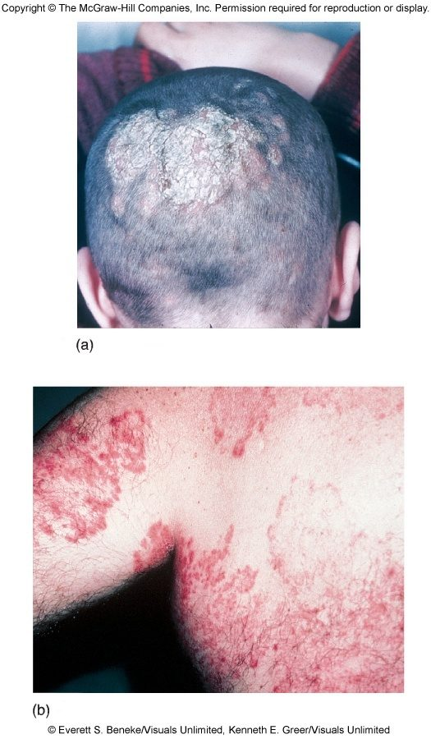
Ringworm of the scalp and body : (a) tinea capitis, a scaly patch with hair loss; (b) tinea corporis, red lesions with raised edges. © Everett S. Beneke/Visuals Unlimited, Kenneth E. Greer/Visuals Unlimited. Copyright © The McGraw-Hill Companies. Source: PAJ5200.Fungi of Medical importance.pptx, Slide 47.
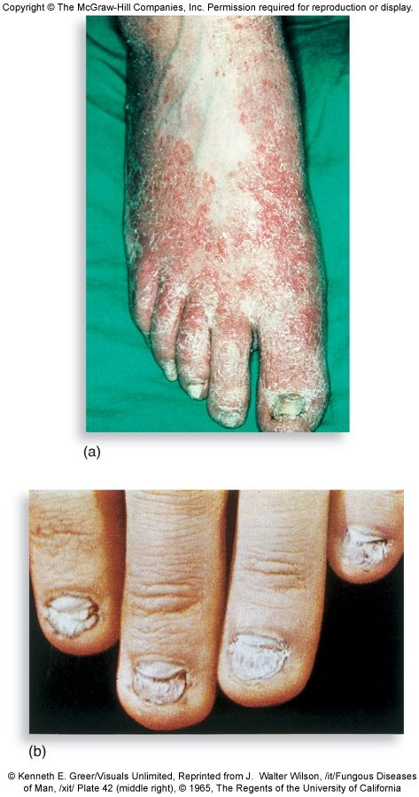
Ringworm of the extremities : (a) tinea pedis; (b) tinea unguium, distorted nails. Copyright © The McGraw-Hill Companies. Source: PAJ5200.Fungi of Medical importance.pptx, Slide 48.

15.14 · Objective 1 — Superficial mycoses
Mycosis | Cause | What it does
Tinea versicolor | A yeast, Malassezia furfur | Mild, chronic scaling and mottling of the skin; also implicated in folliculitis, psoriasis and seborrheic dermatitis
White piedra (piedra = stone) | Trichosporon species | Whitish or colored masses on pubic or axillary hair (also body, beard, mustache, eyebrows)
Black piedra | Piedraia species | Dark-brown to black, gritty nodules, mainly on scalp hairs

Both piedras are considered non-contagious and may result from poor personal hygiene (oily hair products, tight hats or veils). Neither piedra is common in the United States.
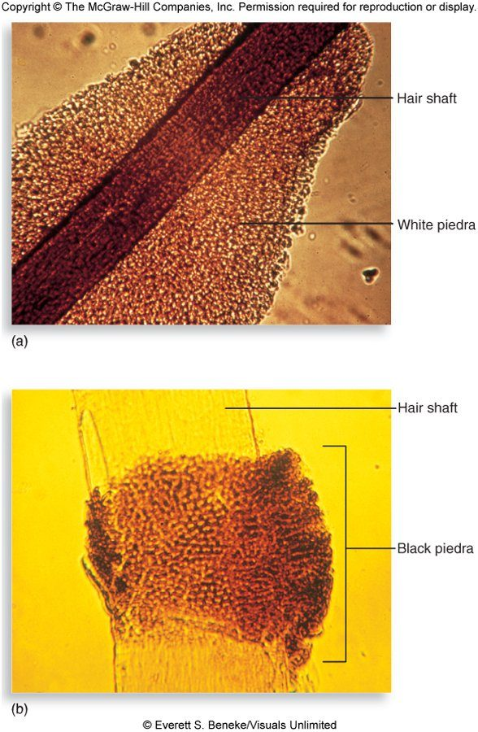
The two piedras on a hair shaft : (a) white piedra; (b) black piedra. © Everett S. Beneke/Visuals Unlimited. Copyright © The McGraw-Hill Companies. Source: PAJ5200.Fungi of Medical importance.pptx, Slide 50.

15.15 · Objective 1 — The opportunistic mycoses
These fungi were once considered “harmless” skin or air contaminants. All have predisposing factors, and the host’s defenses are compromised: Candida species, the dominant opportunistic pathogen; Aspergillus fumigatus, which accounts for most lung infections (the slide’s words; read it as most of the Aspergillus lung infections); Cryptococcus neoformans; Fusarium species; and Rhizopus species.
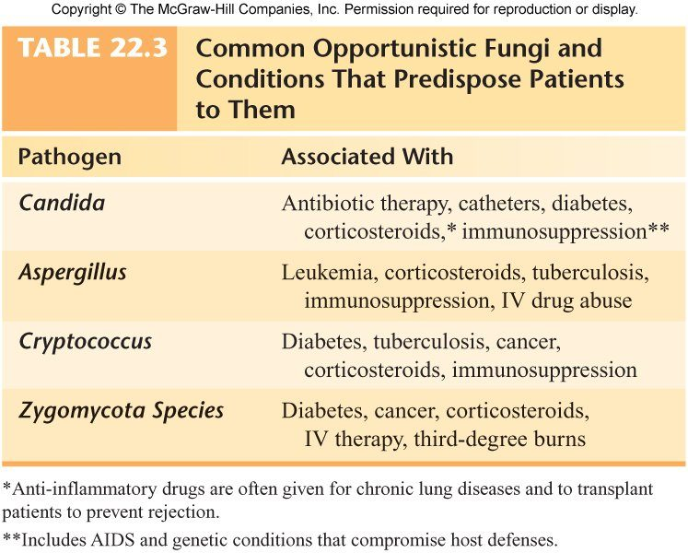
Table 22.3, the predisposing conditions. Candida : antibiotic therapy, catheters, diabetes, corticosteroids, immunosuppression. Aspergillus : leukemia, corticosteroids, tuberculosis, immunosuppression, intravenous drug abuse. Cryptococcus : diabetes, tuberculosis, cancer, corticosteroids, immunosuppression. Zygomycota species: diabetes, cancer, corticosteroids, intravenous therapy, third-degree burns. (Footnotes: anti-inflammatory drugs are often given for chronic lung diseases and to transplant patients to prevent rejection; immunosuppression includes acquired immunodeficiency syndrome and genetic conditions that compromise host defenses.) Copyright © The McGraw-Hill Companies. Source: PAJ5200.Fungi of Medical importance.pptx, Slide 9.
An emerging concern. Mycoses account for a growing share of nosocomial (hospital-acquired) infections, about one in ten and rising, which is why opportunistic fungi are an emerging concern.

15.16 · Objective 1 — Candida and candidiasis
- Candida albicans is the familiar one, but Candida auris is emerging as a serious cause of invasive candidiasis, producing hospital outbreaks that are difficult to eradicate: antifungal drug resistance, thermoresistant, and partially resistant to common disinfectants. C. auris was first identified in Japan in 2009, as the cause of an ear infection, hence the name; cases have increased in recent years.
- Candida auris outbreaks. Hospital outbreaks are hard to eradicate because of drug, heat and disinfectant resistance: it shows antifungal drug resistance, is thermoresistant and is partially resistant to common disinfectants.
- C. albicans is a widespread yeast, usually endogenous and not always considered contagious; it can be spread through surgery, childbirth, breast-feeding and sexual contact.
- Infections range from short-lived, superficial skin irritations to overwhelming, fatal systemic disease in seriously compromised hosts.
- Colony: off-white, pasty, with a yeasty (“baking bread”) odor.
- Normal flora of the oral cavity, genitalia, large intestine or skin of 20% of humans; accounts for 70% of nosocomial fungal infections.
Form | What the slides say
Thrush | A thick, white, adherent growth on the mucous membranes of the mouth and throat (chronic thrush in an adult man with diabetes, slide 54)
Vulvovaginal yeast infection | A painful inflammatory condition of the female genital region with ulceration and discharge; may be transmitted to unprotected sexual partners, especially uncircumcised males
Cutaneous candidiasis | In chronically moist areas of skin and in burn patients; intertriginous lesions (armpits, groin, under the breasts) are common in obese patients

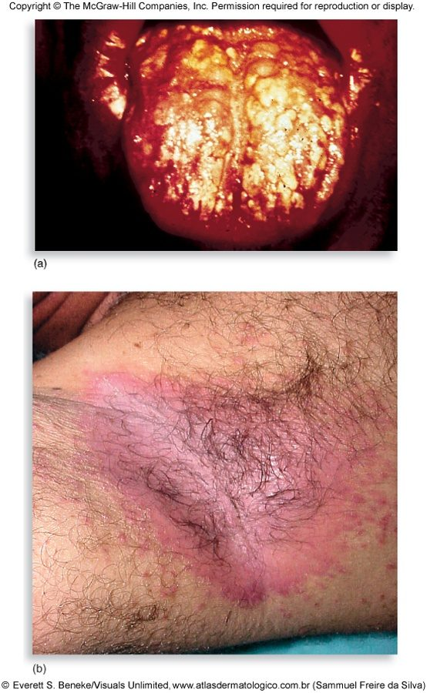
Infections by Candida albicans : (a) chronic thrush in an adult male with diabetes; (b) intertriginous lesions. © Everett S. Beneke/Visuals Unlimited. Copyright © The McGraw-Hill Companies. Source: PAJ5200.Fungi of Medical importance.pptx, Slide 54.
Diagnosis and treatment. A presumptive diagnosis is made if budding yeast cells and pseudohyphae are found; growth on selective, differential media differentiates the Candida species; the germ tube test is on the identification flowchart (15.5). Topical antifungals are used for superficial infections; amphotericin B and azoles for systemic infections.
Telling the Candida species apart. After a presumptive diagnosis of candidiasis, growth on selective, differential media differentiates the Candida species.
Presumptive diagnosis of candidiasis. It is made when budding yeast cells and pseudohyphae are found in a scraping.

15.17 · Objective 1 — Cryptococcus neoformans and cryptococcosis
- The number one critical fungal pathogen on the World Health Organization’s list.
- A widespread encapsulated yeast that inhabits soil around pigeon roosts in urban areas, and soil containing decaying wood.
- Healthy humans are strongly resistant; frank infection occurs in immunocompromised patients (human immunodeficiency virus infection and acquired immunodeficiency syndrome, cancer, immunosuppression, autoimmune disease, diabetes, cirrhosis). Treatment protocols are well established for patients with human immunodeficiency virus infection, though the drugs may be unavailable in many countries.
- Lungs: cough, fever and lung nodules. Dissemination to the meninges and the brain can cause severe neurological disturbance and death.
- Diagnosis: a negative stain shows the encapsulated budding yeast; biochemical and serological testing are the best diagnostic tools.
- Diagnosing cryptococcosis. Biochemical and serological tests are the best diagnostic tools; a negative stain can demonstrate the encapsulated budding yeast.
- A negative stain showing encapsulated budding yeast demonstrates Cryptococcus neoformans, the widespread encapsulated yeast of pigeon-roost soil.
- Treatment: systemic infection generally requires amphotericin B and fluconazole or another azole-class drug.
- Treating systemic cryptococcal infection. It generally requires amphotericin B plus fluconazole or another azole-type drug; treatment protocols are well established for patients with human immunodeficiency virus infection.

15.18 · Objective 1 — Pneumocystis jirovecii and Pneumocystis pneumonia
- Formerly Pneumocystis carinii. A small, unicellular fungus that causes pneumonia; the most prominent opportunistic infection in patients with human immunodeficiency virus infection and acquired immunodeficiency syndrome.
- Immunological evidence such as antibody titer suggests that contact with it is very widespread and most of us remain asymptomatic.
- The pneumonia forms secretions in the lungs that block breathing and can be rapidly fatal if not controlled (cough, fever, shallow respiration and cyanosis). Kidney transplant patients are also at high risk.
- Cysts containing several bodies are the tissue form of Pneumocystis jirovecii; kidney transplant patients are at high risk, and cough, fever, shallow respiration and cyanosis are its pneumonia.
- Treatment: pentamidine (an anti-protozoan) and the antibacterial co-trimoxazole (trimethoprim-sulfamethoxazole); these are NOT the traditional antifungal drugs.
- Its taxonomy is still debated, fungus or protozoan; most scientists lean toward a fungal classification because of genetic analysis.
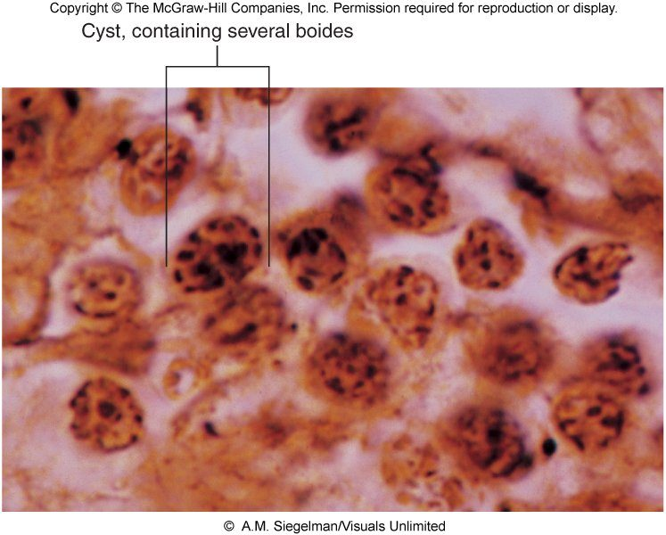
Pneumocystis jirovecii in tissue: a cyst containing several bodies. © A.M. Siegelman/Visuals Unlimited. Copyright © The McGraw-Hill Companies. Source: PAJ5200.Fungi of Medical importance.pptx, Slide 59.

15.19 · Objective 1 — Aspergillus and aspergillosis
- A very common airborne soil fungus; its resistance to azole fungicides can be attributed to agricultural practices (crop spraying to prevent loss to fungi).
- About 600 species, 8 involved in human disease; A. fumigatus is the most common and is number three on the World Health Organization’s critical list.
- A serious opportunistic threat in human immunodeficiency virus infection and acquired immunodeficiency syndrome, leukemia, and transplant patients.
- Infection usually occurs in the lungs: spores germinate and form fungal balls; it can also colonize the sinuses, ear canals, eyelids and conjunctiva.
- Acquiring Aspergillus. Aspergillus is a very common airborne soil fungus: people usually acquire it by breathing in airborne spores, and infection usually occurs in the lungs, where its spores germinate and form fungal balls.
- Invasive aspergillosis can produce necrotic pneumonia and infection of the brain, heart and other organs; transplant recipients (organ and bone marrow) and cystic fibrosis patients are at increased risk.
- Treatment on the slide: amphotericin B and nystatin (see 15.23).
- In a sputum specimen it shows branched septate hyphae (15.5).
- Branched septate hyphae in sputum. A mass of branched septate hyphae, with no yeast cells, in a dye-stained sputum specimen is the picture of Aspergillus species; dyes amplify these fungal elements in tissue specimens.
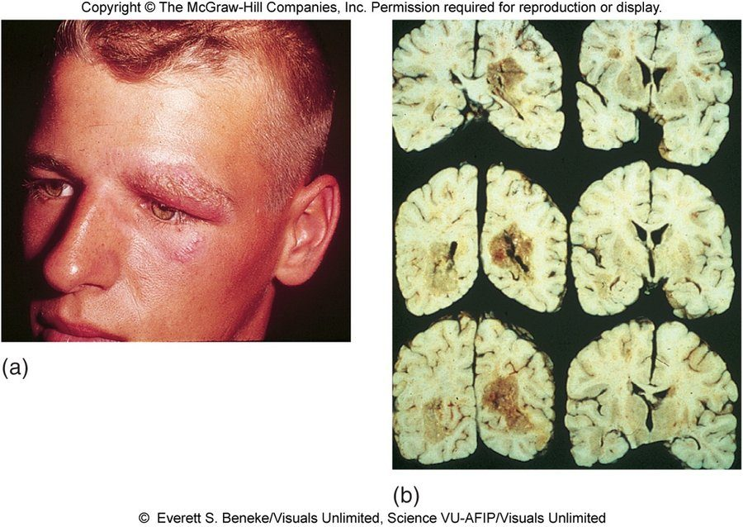
Clinical aspects of aspergillosis : (a) infection around the eye; (b) brain sections with lesions of invasive disease. (Slide 61 also shows a chest X-ray.) © Everett S. Beneke/Visuals Unlimited, Science VU-AFIP/Visuals Unlimited. Copyright © The McGraw-Hill Companies. Source: PAJ5200.Fungi of Medical importance.pptx, Slide 61.
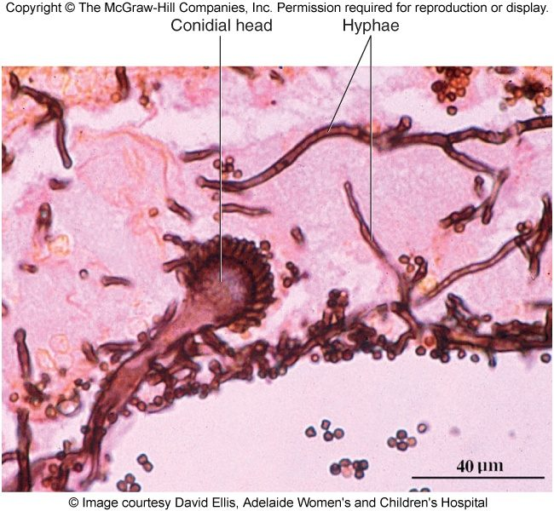
Aspergillus in tissue: a conidial head on hyphae . © Image courtesy David Ellis, Adelaide Women's and Children's Hospital. Copyright © The McGraw-Hill Companies. Source: PAJ5200.Fungi of Medical importance.pptx, Slide 62.

15.20 · Objective 1 — Mucormycosis and other opportunists

Zygomycosis (mucormycosis)
- Members of the Division Zygomycota are extremely abundant saprobic fungi found in soil, water, organic debris and spoiled food.
- Mucormycosis is called “black mold” and has arisen as a big concern in India over the last few years; injudicious use of respiratory steroids and uncontrolled diabetes may have contributed. Rhino-orbital-oral-cerebral symptoms have been documented.
- The fungi most often involved are Rhizopus and Mucor species.
- Usually harmless air contaminants that may invade the membranes of the nose, eyes, heart and brain of people with diabetes, leukemia or malnutrition, with severe consequences. There is also a pediatric gastrointestinal complication in children who lack sufficient protein (kwashiorkor).
- Treatment: removal of affected tissue and amphotericin B.

Miscellaneous fungal opportunists
- Any fungus can be implicated when the host’s immune defenses are severely compromised.
- Fusarium: another mainly tropical soil mold; occasionally infects the eyes (for example from contaminated contact lenses), toenails, feet and burned skin, and can result in severe disability and death.
- Fusarium and the eye. Fusarium species, a mainly tropical soil mold, occasionally infect the eyes, for example through contaminated contact lenses, as well as toenails, feet and burned skin.
- Eumycetomas, deep tissue infections, are especially prevalent in poor countries; risk factors: male, 11–30 years old, farmer, not wearing shoes. Long-term antifungal drug therapy and amputation may be required for full resolution.

15.21 · Objective 1 — Fungal allergies and mycotoxins
- Fungal spores are common sources of atopic allergies or hypersensitivities: seasonal allergies and asthma; farmer’s lung, teapicker’s lung, bark stripper’s disease.
- Fungal toxins cause mycotoxicoses, usually by ingesting or inhaling fungal toxins.
Toxin or mold | What the slide says
Aflatoxin | Hepatotoxic and carcinogenic; grains, corn, peanuts; lethal to poultry and livestock (especially turkeys, ducklings, pigs and calves); in humans it may be a co-factor in liver cancer
Ergot | On rye or other grains contaminated by Claviceps fungi; mind-altering lysergic acid (the slide writes LSD; lysergic acid diethylamide is a semi-synthetic derivative of it); cross-reference Salem, Massachusetts
Stachybotrys chartarum | Sick building syndrome (damp building related illness, the “black mold”; very different from mucormycosis); can cause severe hematologic and neurological damage. Not all molds in buildings are toxic, and not all illnesses in buildings are due to fungi; fear of mold has spawned a whole industry of environmental mold control

15.22 · Objective 2 — Modes of transmission
How people acquire it | Fungi
Inhaling spores from disturbed soil or animal waste | The true pathogens: Histoplasma (soil with bird and bat guano, conidia whipped up by wind), Coccidioides (arthrospores in dust from digging, construction, dust storms), Blastomyces (conidia from forest soil, decaying wood, manure), Paracoccidioides (lung infection by inhalation)
Inhaling spores or yeasts of opportunists | Cryptococcus (soil around urban pigeon roosts), Aspergillus (airborne soil fungus; spores germinate in the lungs), the Zygomycota (air contaminants)
Inoculation through broken or punctured skin | Sporothrix (thorn, wood, bare roots); Paracoccidioides (skin infection by inoculation); true-pathogen spores into broken skin; nail extensions as a portal for tinea unguium
Person to person or by fomites | The dermatophytes (close contact, shared equipment, clothing, bedding, public surfaces; tinea barbae mainly from animals) and Candida (surgery, childbirth, breast-feeding, sexual contact)
Endogenous (already on the body) | Candida albicans, usually endogenous normal flora
Not communicable | Most fungal pathogens; Histoplasma is explicitly not transmitted person to person; the piedras are non-contagious
Ingesting or inhaling toxins | Mycotoxicoses: aflatoxin (grains, corn, peanuts), ergot (rye)

15.23 Where the slides disagree, and where current practice differs
- Immunity after a true fungal pathogen. Slide 15 says long-term immunity “can only develop against a few true fungal pathogens”; slide 24 says “all of the diseases caused by the true fungal pathogens can result in immunity in a competent host”. No question asks which, or how many; the contrast with the opportunists (reinfection highly likely) is the same on both slides.
- Amphotericin B routes (slide 20). The slide calls it versatile, given topically, orally, by intramuscular injection or intravenously. In current practice it is given intravenously for systemic infection; it is not given by intramuscular injection and is poorly absorbed by mouth. Not asked.
- Why amphotericin B is toxic (slide 20). The slide gives the reason as fungi and humans both being eukaryotes, so the drug is not selective enough. Pharmacology references add the mechanism: it binds ergosterol in fungal membranes but also binds some cholesterol in human membranes. One quiz question asks this, keyed as the slide says.
- Aspergillosis treatment (slide 60). The slide lists amphotericin B and nystatin. Nystatin is a topical and oral (non-absorbed) agent and current practice does not use it for invasive aspergillosis (azoles such as voriconazole are used). Not asked.
- Temperatures. Slide 5 gives mold at 30 °C and yeast at 37 °C; the slide 6 figure gives the ranges below 30 °C and 35–40 °C, and slide 27 grows the mold below 35 °C. They agree on direction; the quizzes use slide 5’s two numbers.
- “Black mold.” Slide 63 calls mucormycosis “black mould”; slide 65 calls Stachybotrys the “black mold” and says the two are very different. Know them apart by what they do: mucormycosis invades tissue (nose, eyes, brain) in diabetes and leukemia; Stachybotrys is the sick building mold.
- Spellings. The deck’s “Blastomyces dermatiditis” (slide 34) is Blastomyces dermatitidis, as slide 33 spells it; “mould” is written mold here.
Source: Fungi of Medical Importance (PAJ5200.Fungi of Medical importance.pptx), Slides 1–65, and the PAJ 5200 syllabus instructional objectives.

16 · Significant Microorganisms in Food Safety
Dr. Fair · Lecture 16 · 30 October 2026
INSTRUCTIONAL OBJECTIVES
- Identify sources of microbial contamination in global food supply.
- Correlate associations between contaminated foods with the increasing numbers of diagnosed food-borne illnesses and mortality worldwide.
- Analyze associations between public concern and antibiotic resistant strains of microbes in the food supply.
- Correlate associations between improved laboratory analytical methods with respect to near-daily announcements of food recalls and food-related illness.

NOTE
Food, the microbe, the illness, the trace. Microbes are in food on purpose (bread, beer, cheese, yogurt), by accident (spoilage) or as passengers (16.1). The dangerous ones come from animals, feces, soil and water (16.2). Then the organism list, each with its food and its illness: the first split is intoxication (a preformed toxin: staphylococcal toxin, botulinum toxin) against infection (live cells that multiply: Salmonella, Listeria), 16.4. The seven bacteria are Escherichia coli, Salmonella, Campylobacter jejuni, Listeria monocytogenes, Clostridium, Bacillus cereus and Vibrio (16.5–16.11), then fungi, protozoa, worms and viruses (16.12–16.13). Last, how outbreaks are traced: pulsed-field gel electrophoresis patterns in the PulseNet database (16.14). Objective 3, antibiotic resistance, has no slide (16.15).

★ PROFESSOR EMPHASIS
★ From the lecture recording — 30 October 2026
Not read yet. This lecture was recorded on 30 October and the recording is being transcribed (ours, plus Notability’s own transcript as a second opinion). Until it has been read, this section is built from the slides alone, and the quizzes are weighted by slide count. When the recording has been read, this box will carry what Dr. Fair stressed, what she said to skip, whether she covered objective 3 (antibiotic resistance, which no slide teaches), and any correction of a slide (16.17 lists the ones worth listening for).

16.1 · Objective 1 — Microbes in food: production and spoilage
Effect of microbes on food | What it means
Beneficial | Food fermented or otherwise chemically changed by added microbes or microbial products, to alter or improve its flavor, taste or texture
Detrimental | Food poisoning, food intoxication, food-borne illness and food spoilage: food unfit to eat because of undesirable flavors, appearance or smell
Neutral | Microbes present that neither cause disease nor change the food: “they’re just there and we consume them with the food”

Bread making
Microbes have three main functions: (1) leavening flour-based dough (mainly carbon dioxide and other gases); (2) imparting flavor and aroma (organic acids and alcohols); (3) conditioning the dough to make it pliable and workable (microbial enzymes act on gluten to give elasticity). Microbes involved: Saccharomyces cerevisiae (baker’s yeast), certain Clostridium species, and certain Lactobacillus species (Lactobacillus sanfrancisco in sourdough).

Beer, wine and other fermented products
- Glucose + yeast → 2 ethanol + 2 carbon dioxide (C6H12O6 → 2C2H5OH + 2CO2). Evidence of beer brewing since 6000 BCE in Sumeria, Egypt and Babylon. Steps: malting of the starch source, mashing, wort plus hops, lagering, filtration.
- Wine usually starts with grapes, but other fruit and plant material can be used (apples, oranges, pineapples, peaches, plums).
- Sometimes the source of yeast for an alcoholic beverage is human saliva: chewing (mastication) of the plant material precedes the brewing.
- Pickling: salt brine preserves vegetable material; lactic acid may also be present, with vinegar and spices. Cucumbers, cabbage, olives, okra, onions, ginger root and many more can be pickled.
- Soybeans and their extracts are fermented into tofu and soy sauce (shoyu); also fermented fish sauce, mole (chocolate), tea and coffee.

Milk and dairy
- Milk begins sterile: water, minerals, protein, butterfat, lactose and other sugars. Microbes are introduced as it exits the female mammal’s body and by milking utensils; it is highly susceptible to microbial growth because of its nutrient density.
- How microbes first get into milk. Milk begins as a sterile mixture; microbes are introduced on leaving the animal, as it exits the female mammal's body, and from milking utensils.
- Fermentation of milk can be natural or induced (cheese or yogurt making). Cheese making is about 5000 years old (cow, goat or sheep milk; some cultures horse or water buffalo). The first fermented dairy products were probably due to accidental contamination with human skin, nose or oral bacteria and fungi. Cheese making involves yeast, bacteria and molds (multicellular fungi).
- Yogurt is a fermented milk made with bacteria such as Lactobacillus and Streptococcus; other fermented milks are kefir, koumiss and buttermilk.

Microbes as food, and fungi in food
- Macroscopic fungi and algae are obvious foods: mushrooms, truffles, seaweed. Microbial additives for animal feed are already used; human versions are slower to be accepted. “Single cell protein” and bacterial or fungal products are being researched in the United Kingdom and elsewhere. In the United States the cyanobacterium Spirulina is added to foods such as smoothies and vitamin supplement gummies.
- Fungi do not commonly cause disease but are associated with both food production and food spoilage: importance in food (mushrooms), in medicine (they produce penicillin), and in industry (yeasts are fungi used to ferment many products). Fungal spoilage: bread, cereals and acidic juices.

16.2 · Objective 1 — Where foodborne microbes come from
Source | Organisms and foods on the slides
Feces (human and animal) | Escherichia coli, the indicator organism of feces: fecally contaminated meats or vegetables. Norovirus and hepatitis A and E: feces (and vomitus), shellfish from feces-contaminated water
Animals, especially poultry | Salmonella: many animals, mainly poultry and aquatic reptiles. Campylobacter: raw poultry. Listeria: birds and mammals. Parasitic worms: venison, pork and other meat contaminated while the animal is still alive; domestic pet feces (tapeworm, roundworm)
Soil and plants | Listeria persists in soil. Clostridium spores: soils, plants, honey
Water | Vibrio: salt-tolerant, in ocean and estuarine waters. Protozoa: drinking water and uncooked fruit and vegetables
People | Norovirus person to person; the carrier cook (16.6); milk picks up microbes as it leaves the animal and from utensils

16.3 · Objective 2 — The size of the problem, and who watches it
- An estimated 250 different foodborne pathogens, with bacteria the most common.
- The slide gives 75 million cases a year “worldwide” (probably under-reported) and at least 5000 deaths: a serious problem for global health (see 16.17).
- Recorded counts are probably too low. The yearly estimate of foodborne illness is probably an under-reported number, and Campylobacter jejuni illness in particular is very much under-reported, so recorded counts likely understate the true burden.
- The worry is not only bacteria from plant and animal sources but also viruses, parasites and toxins produced by microorganisms.
- Plant foods carry bacteria too. The worry about bacteria covers food from both plant and animal sources: Escherichia coli outbreaks have come from bagged spinach and romaine lettuce, and Salmonella recalls have included watermelon, onions, cantaloupe and cucumbers, so avoiding animal foods does not remove the risk.
- Surveillance and outbreak investigation: local and state health departments, the Centers for Disease Control and Prevention, the Food and Drug Administration, the United States Department of Agriculture. Law enforcement and policy: the Food and Drug Administration and the United States Department of Agriculture.
- Law enforcement and policy. Local and state health departments, the Centers for Disease Control and Prevention, the Food and Drug Administration and the United States Department of Agriculture all conduct surveillance and investigate outbreaks, but enforcing food safety law and policy rests with the Food and Drug Administration and the United States Department of Agriculture.
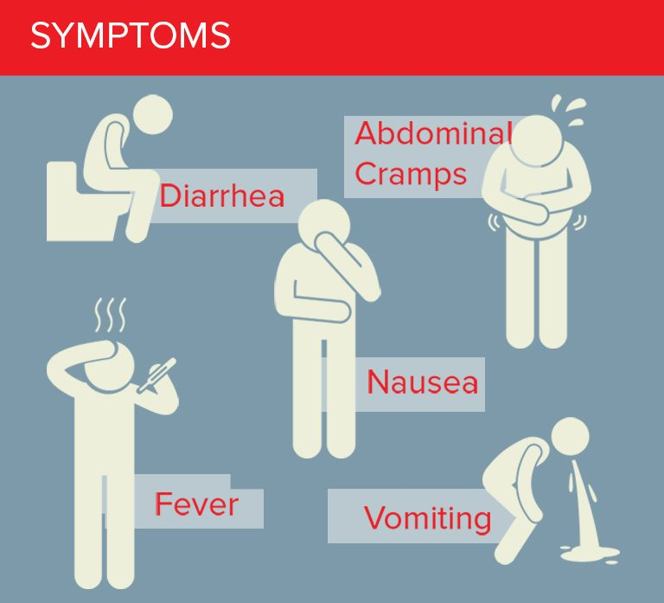
The symptoms of foodborne illness : diarrhea, abdominal cramps, nausea, fever and vomiting. (Slide 11, pictures only, shows bismuth subsalicylate packaging, an upset stomach reliever and antidiarrheal, beside a blackened tongue; it has no text.) Source: PAJ5200.FoodSafety-micro.pptx, Slide 10.
The better-known bacteria of the lecture (slide 13): E. coli, Salmonella species, Campylobacter jejuni, Listeria monocytogenes, Clostridium species, Bacillus cereus, and Vibrio species such as vulnificus or parahaemolyticus. Organisms other than bacteria (slide 30): fungi, protozoa, parasitic worms (in pork, venison, wild-caught fish) and viruses.

16.4 · Objective 2 — Food intoxication versus food infection
Kind of illness | What is eaten | What happens | Examples (slide 12)
Food intoxication | A preformed toxin made by the bacteria in the food (cells and toxin) | The toxin is ingested and reaches its target organs (the diagram shows the brain and muscles) | Staphylococcal toxin, Clostridium botulinum toxin
Food infection | Live bacterial cells | Improper cooking lets the bacteria multiply in the food; after ingestion they cause an intestinal infection | Salmonella, Listeria

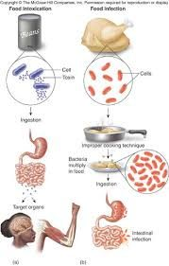
(a) Food intoxication; (b) food infection. Copyright © The McGraw-Hill Companies. Source: PAJ5200.FoodSafety-micro.pptx, Slide 12.

16.5 · Objective 2 — Escherichia coli
- EMB (eosin methylene blue) plates are often used to confirm E. coli in samples (food, water).
- An “indicator organism” associated with human and animal feces.
- Found everywhere, including inside humans, but not always pathogenic; it has many good traits too.
- Not every strain is pathogenic. Escherichia coli is found everywhere, including inside humans, but it is not always pathogenic and has many good traits too; illness comes from the bad strains.
- As an infectious agent it causes nausea, vomiting and diarrhea. The bad strains can carry numerous toxins (for example the enterotoxigenic or enterohemorrhagic strains).
- Sporadic outbreaks originate from fecally contaminated meats or vegetables (the Jack in the Box hamburgers, bagged spinach). One of the worst culprits is the O157:H7 serotype.
- The outbreak and recall list (slide 16): hamburgers (1993), California bagged spinach (2006), refrigerated cookie dough (2009), romaine lettuce (2010, 2018 from Arizona, 2020–2021 from California), 7% of fresh spinach in grocery stores carrying E. coli (a 2013 report), beef products (2019), ground beef from packing companies (2023–2025), and raw milk cheese in the western United States (September–October 2026).
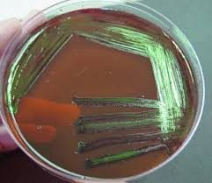
An eosin methylene blue plate : the growth with a green metallic sheen. These plates are used to confirm E. coli in food and water samples. Source: PAJ5200.FoodSafety-micro.pptx, Slide 14.

16.6 · Objective 2 — Salmonella
- The main species are Salmonella typhi, S. enterica, S. enteritidis and S. typhimurium; others are named for where they were first found (S. miami, S. heidelberg, S. sandiego).
- Associated with many animals, mainly poultry and aquatic reptiles.
- Salmonellosis can appear as gastroenteritis, enteric fever, septicemia (blood infection), fever, shock and kidney dysfunction. Incubation can be as short as hours or as long as weeks.
- Young children and the elderly are at greatest risk.
- Elderly people, on both risk lists. Young children and the elderly are at greatest risk for salmonellosis, and elderly people are also among those at greatest risk for listeriosis, so the elderly are the group on both lists.
- Typhoid fever (S. typhi) is the most severe enteric fever: the intestinal wall is invaded and the bacteria can spread to the blood and lymph nodes.
- Typhoid fever, caused by Salmonella typhi, is the most severe enteric fever, marked by invasion of the intestinal (gut) wall, with possible spread to the blood and lymph nodes.
Sources (slide 18): poultry products (chicken, turkey, duck), eggs, pet food, live poultry (such as backyard hens), peanut butter and sushi-grade seafood. Recalls have included peanuts and peanut butter (2009), hydrolyzed vegetable protein (2010), farm eggs (2010), ground turkey (2011), pre-cut watermelon (2018), turkey and pork products (2019), onions from Mexico (2021), pre-cut cantaloupe (2023), cucumbers from Florida and Mexico (2025) and jalapeno peppers (August 2026): produce, not just animal foods. Slide 19 pictures peanut butter jars, eggs, a pet turtle and a watermelon recall.

“Typhoid Mary.” Mary Mallon, a cook: “She was warned. She was given an explanation. Nevertheless, she persisted. And caused multiple deadly outbreaks.” Slide 20 also shows Salmonella rods and two agar plates. Source: PAJ5200.FoodSafety-micro.pptx, Slide 20.
Mary Mallon, “Typhoid Mary.” She was warned and given an explanation, yet she kept cooking despite warnings: she persisted in preparing food, causing multiple deadly outbreaks.
Live backyard hens. Keeping live poultry such as backyard hens is a Salmonella source, alongside poultry products, eggs and pet food.
Eggs and peanut butter. Both are Salmonella sources, and Salmonella recalls have included peanuts and peanut butter and farm eggs.

16.7 · Objective 2 — Campylobacter jejuni
- A leading cause of bacterial diarrheal disease each year in the United States, especially in children.
- Fever, headache, dizziness and bloody diarrhea, usually rapid in onset.
- The infectious dose is less than 500 bacterial cells, so even one drop of raw poultry fluid can cause illness.
- Poultry, including its leftovers. Even one drop of raw poultry fluid can cause Campylobacter jejuni illness, so holiday poultry and its leftovers deserve particular care.
- Very much under-reported. Be careful with Thanksgiving poultry and leftovers.
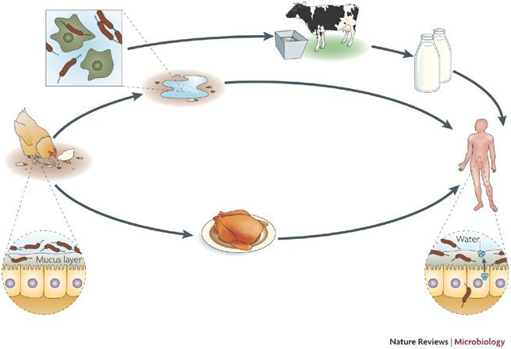
How Campylobacter reaches people : chickens and water, cattle and milk, and poultry meat, all leading to the human gut. Nature Reviews Microbiology. Source: PAJ5200.FoodSafety-micro.pptx, Slide 21.
The Campylobacter jejuni transmission cycle reaches people by three routes: poultry meat, contaminated water, and milk from cattle.

16.8 · Objective 2 — Listeria monocytogenes
- Found in birds and mammals, and can persist in soil.
- Large-scale food recalls: the big ice cream recall of 2016 (Blue Bell, slide 22), cantaloupes, frozen vegetables, poultry (2019).
- Greatest risk of listeriosis: pregnant women, unborn children, premature babies, elderly people and the immunocompromised.
- The slide calls it “the #1 cause of food-related deaths in the US” (see 16.17).
- Number one cause of food-related deaths. Listeria monocytogenes is the number one cause of food-related deaths in the United States.
- Most vulnerable foods: soft cheeses, raw fruit and vegetables, raw or undercooked meats, deli meats, seafood, smoked seafood, hot dogs, preserved meats.
- Probably the biggest concern: it grows well from 1 to 40 °C, easily at refrigerator, room or freezer temperatures (the slide’s words; freezer temperatures sit below its own 1 °C floor, so see 16.17).
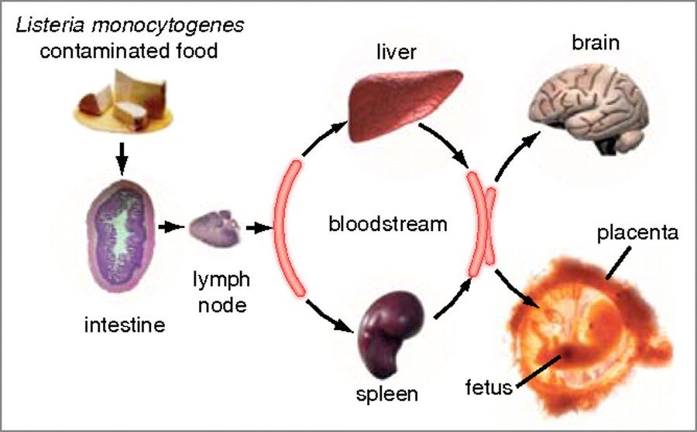
Where Listeria goes : contaminated food → intestine → lymph node → bloodstream (liver, spleen) → brain , and across the placenta to the fetus . Source: PAJ5200.FoodSafety-micro.pptx, Slide 24.

16.9 · Objective 2 — Clostridium and botulism
- Gram-positive rods, strict anaerobes, form spores.
- Notable species: C. botulinum and C. perfringens; C. tetani (not food-related) and C. difficile (also not food-related).
- Spores are found in soils, associated with plants, and even in honey (slide 26 shows a raw honey label).
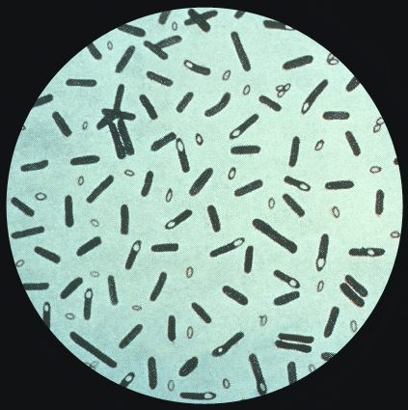
Clostridium : rods carrying spores. Source: PAJ5200.FoodSafety-micro.pptx, Slide 25.
Clostridium botulinum | Slide 27
Toxin | When spores germinate they can start producing toxin: botulinum toxin (“botox”)
Forms | Foodborne and wound-borne botulism are known to occur
Effect | Ingesting the toxin leads to paralysis of the muscles in the relaxed position, then respiratory failure and death
Dose | Even if only a few bacteria are present, they can produce plenty of toxin

16.10 · Objective 2 — Bacillus cereus
- A very common food poisoning agent, especially in summertime.
- Gastroenteritis from B. cereus is either diarrheal or emetic.
- Intoxication has a rapid onset (6 hours or less) with self-resolving vomiting and abdominal cramps.
- Fried rice at a summer picnic. Vomiting and abdominal cramps within a few hours of eating fried rice point to Bacillus cereus: its emetic form is often associated with rice, and the intoxication has a rapid onset (6 hours or less).
- Keep hot foods hot and cold foods cold.
Form | Toxin, as the slide gives it | Food
Diarrheal | Heat-stable toxin (see 16.17) | Meat
Emetic | Heat-labile toxin (see 16.17) | Rice

16.11 · Objective 2 — Vibrio
- Several species: Vibrio cholerae, V. vulnificus and V. parahaemolyticus.
- Salt-tolerant bacteria of ocean and estuarine waters.
- Two major routes: water (ingested, or wound infections) or foodborne (shellfish, crabs, raw seafood, oysters).
- The “R-month” rule (no oysters, clams or mussels in May, June, July and August): “maybe, maybe not”; aquaculture practices have advanced so much that there are fewer worries.

16.12 · Objective 2 — Fungi, protozoa and parasitic worms
- Fungi: rarely disease, mostly production and spoilage (16.1).
- Protozoa: Cryptosporidium, Cyclospora, Giardia, Entamoeba. All can cause mild, usually self-limiting diarrhea associated with uncooked fruits and vegetables or drinking water. Ready-to-eat salad bags are a common culprit.
- Protozoan diarrhea sources. Protozoans such as Cryptosporidium, Cyclospora, Giardia and Entamoeba cause mild diarrhea associated with uncooked produce (fruits and vegetables) and drinking water.
- Parasitic worms: tapeworm, roundworm, trichinosis. Best killed by thorough cooking. Venison, pork and other meats can be contaminated while the animal is still alive: the muscle or organ meats may be suspect. Domestic pet feces can carry tapeworm and roundworm.

16.13 · Objective 2 — Foodborne viruses
Virus | How common | Spread | Course
Norovirus (Norwalk-like viruses, family Caliciviridae) | A common foodborne agent, upwards of 23 million cases a year | Person to person, by feces and vomitus (daycares, nursing homes, cruise ships); also contaminated shellfish (feces-contaminated water) | Infectious dose only a few viral particles; rapid onset and short duration: nausea, vomiting, diarrhea, low-grade fever
Hepatitis A and E | Hepatitis viruses A–E exist; A and E are the ones typically spread by the fecal-oral route | Fecal-oral; not by kissing, sneezing, saliva or blood | A person is most contagious about two weeks BEFORE symptoms appear

Why norovirus spreads so readily. A few viral particles can infect: its infectious dose is only a few viral particles, and it spreads person to person through feces and vomitus in daycares, nursing homes and cruise ships.
Prevention, for both: Good handwashing and diaper hygiene; cook food thoroughly; clean drinking water. For hepatitis, a vaccine in case of suspected exposure (the slide does not say which; see 16.17).

16.14 · Objective 4 — Laboratory methods, tracking and recalls
- A pulsed-field gel electrophoresis pattern for each microbial isolate is added to a database run through the Centers for Disease Control and Prevention: “PulseNet”.
- It can help determine the causes of outbreaks or even detect problems at food processing plants.
- This surveillance reduces the detection time and the number of cases of illness.
- In the laboratory, eosin methylene blue plates confirm E. coli in food and water samples (16.5).
- Online resources: Foodsafetynews.com, Foodsafetymagazine.com, the Centers for Disease Control and Prevention (PulseNet), the Food and Drug Administration (food and dietary supplement recalls, including pet food) and the United States Department of Agriculture (food recall information).
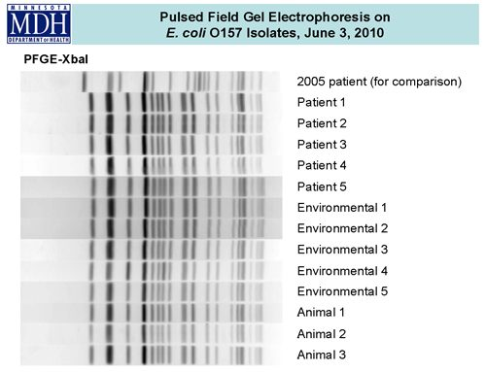
Pulsed-field gel electrophoresis on E. coli O157 isolates (Minnesota Department of Health, 3 June 2010): the patient, environmental and animal isolates share one banding pattern, which ties the cases to a common source; the 2005 patient’s pattern differs. Source: PAJ5200.FoodSafety-micro.pptx, Slide 34.

16.15 · Objective 3 — Antibiotic-resistant strains in the food supply
No slide teaches this objective. The deck’s objective slide lists it, but none of its 36 slides mentions antibiotic resistance, antibiotic use in food animals or resistant strains in food. Nothing is added here from outside the slides, and no quiz question asks it. If the recording covers it, the audio pass will say what was said; otherwise ask Dr. Fair whether it is examinable.

16.16 · What you can do: prevention
- Good handwashing with hot, soapy water.
- Wash fruits and vegetables.
- When in doubt, toss it out.
- When in doubt, toss it out. Leftover cooked chicken that has sat in the refrigerator for an unknown time should be tossed out rather than risk it, even if it smells normal: Listeria monocytogenes grows well at refrigerator temperatures.
- Clean kitchen surfaces and utensils with mild bleach cleaning solutions.
- When cooking meat, use a meat thermometer (165 °F) rather than guessing.
- Cutting board and knife materials; avoid cross-contamination of cutting boards and utensils.
- Proper use of disposable gloves in food service; hair coverings and food service attire; “ServSafe” training and certification.
- From the Bacillus cereus slide: keep hot foods hot and cold foods cold. From the viruses slide: handwashing and diaper hygiene, thorough cooking, clean drinking water.

16.17 Where the slides and current references differ
The quizzes key what the slides say (we are tested from the slides). These are the points where current references say something else; the recording may settle them.
- Bacillus cereus toxins (slide 28). The slide gives the diarrheal form a heat-stable toxin and the emetic form a heat-labile one. Standard references say the reverse: the emetic toxin (with rice) is the heat-stable one, and the diarrheal enterotoxin (with meat) is heat-labile. One quiz question asks this pairing, keyed as the slide says.
- The case and death figures (slide 9). “75 million cases per year worldwide” and “at least 5000 deaths” match older United States estimates rather than worldwide ones; World Health Organization estimates for the world are far larger. Not asked.
- Listeria as the “#1 cause of food-related deaths in the US” (slide 23). National estimates rank nontyphoidal Salmonella above Listeria for total deaths; Listeria has one of the highest death rates per case. Keyed as the slide says.
- 165 °F (slide 36). Food-safety agencies give 165 °F for poultry, leftovers and casseroles, and lower internal temperatures for other meats (160 °F for ground meat, 145 °F for whole cuts with a rest). Keyed as the slide says.
- Listeria at freezer temperatures (slide 23). The slide gives a growth range of 1 to 40 °C and also says it grows easily at freezer temperatures, which are below that range. References say it survives freezing and grows at refrigerator temperatures. The quizzes ask only the 1–40 °C range and refrigerator growth.
- The hepatitis vaccine (slide 33). The slide says there is a vaccine in case of suspected exposure without naming the virus. That fits hepatitis A; there is no licensed hepatitis E vaccine in the United States.
- PulseNet’s method (slide 34). The slide describes PulseNet with pulsed-field gel electrophoresis patterns, which is how it worked for decades; PulseNet has since moved to whole genome sequencing. The quizzes ask what the slide says.
- Names. The deck’s “S. enteriditis” is S. enteritidis; “parahemolyticus” is parahaemolyticus.
Source: Significant Microorganisms in Food Safety (PAJ5200.FoodSafety-micro.pptx), Slides 1–36, and the PAJ 5200 syllabus instructional objectives.

